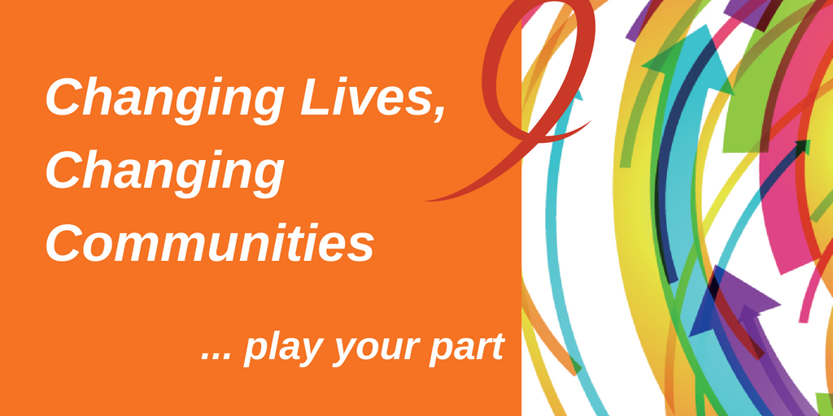
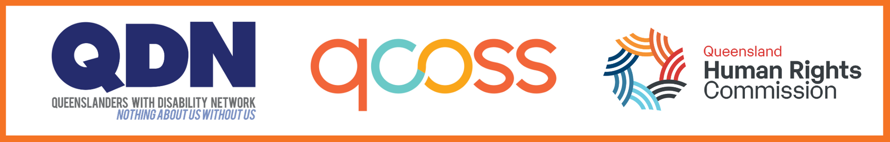

Changing Lives, Changing Communities: Normanton Momentum Meeting

Venue: Bynoe Hall, Corner Woodward and Balonne Streets, Normanton

Date: 16 October 2019
Changing Lives, Changing Communities: Normanton Momentum Meeting 1
About Changing Lives, Changing Communities momentum meetings 3
Who hosted the meeting? 3
Who was in the room? 3
Acknowledgment of Country 4
QDN acknowledgement 4
World Café 4
Outcomes and impact 4
Project updates and discussions 5
Next wise steps 7
Check out 7

About Changing Lives, Changing Communities (CLCC) momentum meetings
In 2018/19, QCOSS, Queenslanders with Disability Network (QDN) and Queensland Human Rights Commission (QHRC, formerly Anti Discrimination Commission Queensland) held 12 Changing Lives, Changing Communities events across Queensland. These two-day events created new ways for people of each community to come together, envision and co-create solutions by asking, “What will it take to create communities where everyone contributes, matters and belongs?”
To continue building our movement for change from the events, QCOSS has planned a momentum meeting in each of the locations. These meetings continue to keep people in the community engaged and excited for the next Changing Lives, Changing Communities events.

This document brings together the highlights from the meeting in 2019 in Normanton. These notes have been summarised and written by the hosting QCOSS staff and are not direct quotes from the participants of the meeting.

Who hosted the meeting?
Lead host – Louise Abson, QDN
Secondary host – Paul Mackay, QCOSS, Senior Community Capacity Officer

Who was in the room?
Patricia Richards, Department of Aboriginal and Torres Strait Islander Partnerships (DATSIP)
Cherie Schafer, Carpentaria Shire Council
Tony Melksham, QDN
Jenny Tommerup, National Disability Insurance Agency (NDIA)
Paul Mackay, QCOSS
David Lily, Centacare North Queensland
Louise Abson, QDN
Georgia Dray, NDIA

Acknowledgment of Country

Louise Abson from (QDN)
Kukatj, Kurtijar and Gkuthaarn Country
I would like to acknowledge the traditional custodians of the land on which we meet today and pay my respect to Elders past, present and emerging. In Normanton we acknowledge the Kukatj, Kurtijar and Gkuthaarn people and recognise their continuing connection to land, waters and community. I pay my respects to them and their cultures.

QDN acknowledgement

Louise Abson from (QDN)
We also acknowledge people with disability who have come before us and died in institutional settings, as well as those who are still trapped in institutions or silenced by institutional practices. We take on the responsibilities of being clear about the rights of ALL people with disability and, where necessary, speak in an informed and considered manner, for those who cannot speak for themselves

World Café

How can we improve on when facilitating the next CLCC?
The following points were made:
- It all worked really well
- It was surprising how unified the group was
- There was a good turn out.
Therefore, there is not much to improve on. A similar method of facilitation would be good.

Was there anyone missing?
The following people were suggested:
- Social workers from Gidgee Healing
- Nursing staff from the Department of Health
- School captains

Outcomes and impact

What’s happened since we last met?
The council has employed a grant writer that will support not-for-profit organisations and groups to develop funding applications.

Project updates and discussions

Project One: Normanton
Host: Anthea Amus and Rebecca Casey (North West Remote Health)
Question: Access in the community
- Council yet to complete the audit. They are calling for individuals to support the process
- Individual community members are encouraged to make submissions/complaints to individual business where there is seen to be a lack of access

Project Two: Normanton
Host: Lee-Anne Pringle
Question: Is there an activity in Normanton where adults and children with disability can come together to pass on and share ideas and connections so they can learn from each other?
Tony has been supporting a group of people to come together. However, he highlighted the following barriers:
- Transportation to and from the group
  - ACTION (Lou): Seek access to Bynoe bus for community pick-up
- Afternoon meeting don’t suit everyone, bus access is normally in the mornings
  - ACTION (Tony): schedule the upcoming meetings in the morning
- Support needs of those that participate in the group meet-ups need support beyond what Tony can give
  - ACTION (Tony): Encourage people to schedule their regular support worker on at the time of the meetings so that they can help with general running of the meetings

Project Three: Normanton
Host: Georgia Dray
Question: Access day for NDIS
- Georgia read out an email that confirmed the dates of the access day as 10, 11 and 12 December
- Jenny will be coming to Normanton on the 29 – 31 November to prepare the community for the event
- The TAFE is seen as the most appropriate venue as it has good accessibility
- Transport is being provided by NWRH, Gidgee and Bynoe
- (ACTION (Georgia): Confirm transport with these organisations
- Brendon will do flyer for the event
- ACTION (Lou): confirm with Brendon, through NWRH

Project Four: Normanton
Host: Peter Midlan (Centacare Normanton)
Question: Men’s business
- The men's group hasn’t met for three months
- The momentum was lost due to the work commitments of the those that were driving the men's group
- The structure of the men's group was to meet regularly, undertaking a planned activity. The activities were centered on health (RUOK days, Sexual Health, Wellbeing Activities, MH awareness), and included movie nights and guest speakers
- To continue, the men’s group needs funding for activities, equipment, and food. The group needs to be sponsored or auspiced by a registered body, so that the usual governance, including insurance, is covered
- There are several opportunities that have arisen but so far not realised because of a lack of coordination
- Currently, there is an opportunity to bring men together again, and reignite the purpose of the men's group through an upcoming camp. The camp is an initiative of Ernie Dingo, loosely termed ‘a healing camp’.

Project Five: Normanton
Host: Tony Melksham
Question: More employment
- There has been some success with the campaign centered on Brendon’s flyer to employ support workers
- Bynoe has initiated the “1000 jobs project” across the Gulf.

Next wise steps

As a community, what will it take to continue the momentum of Changing Lives, Changing Communities?
- Lou: Send around an email monthly for members to update the progress of their projects
- Paul: Follow up with projects in December and offer support where possible.

Check out
Thanks to everyone who came along to Changing Lives, Changing Communities Momentum meeting in Normanton. You have made a difference!
Changing Lives, Changing Communities Mount Isa is a proud partnership between: Queenslanders with Disability Network (QDN), Queensland Council of Social Service (QCOSS), and Queensland Human Rights Commission. (End of document)

