

  - Game Changers: Making sure everyone can get a job after the Brisbane 2032 Olympics and Paralympics

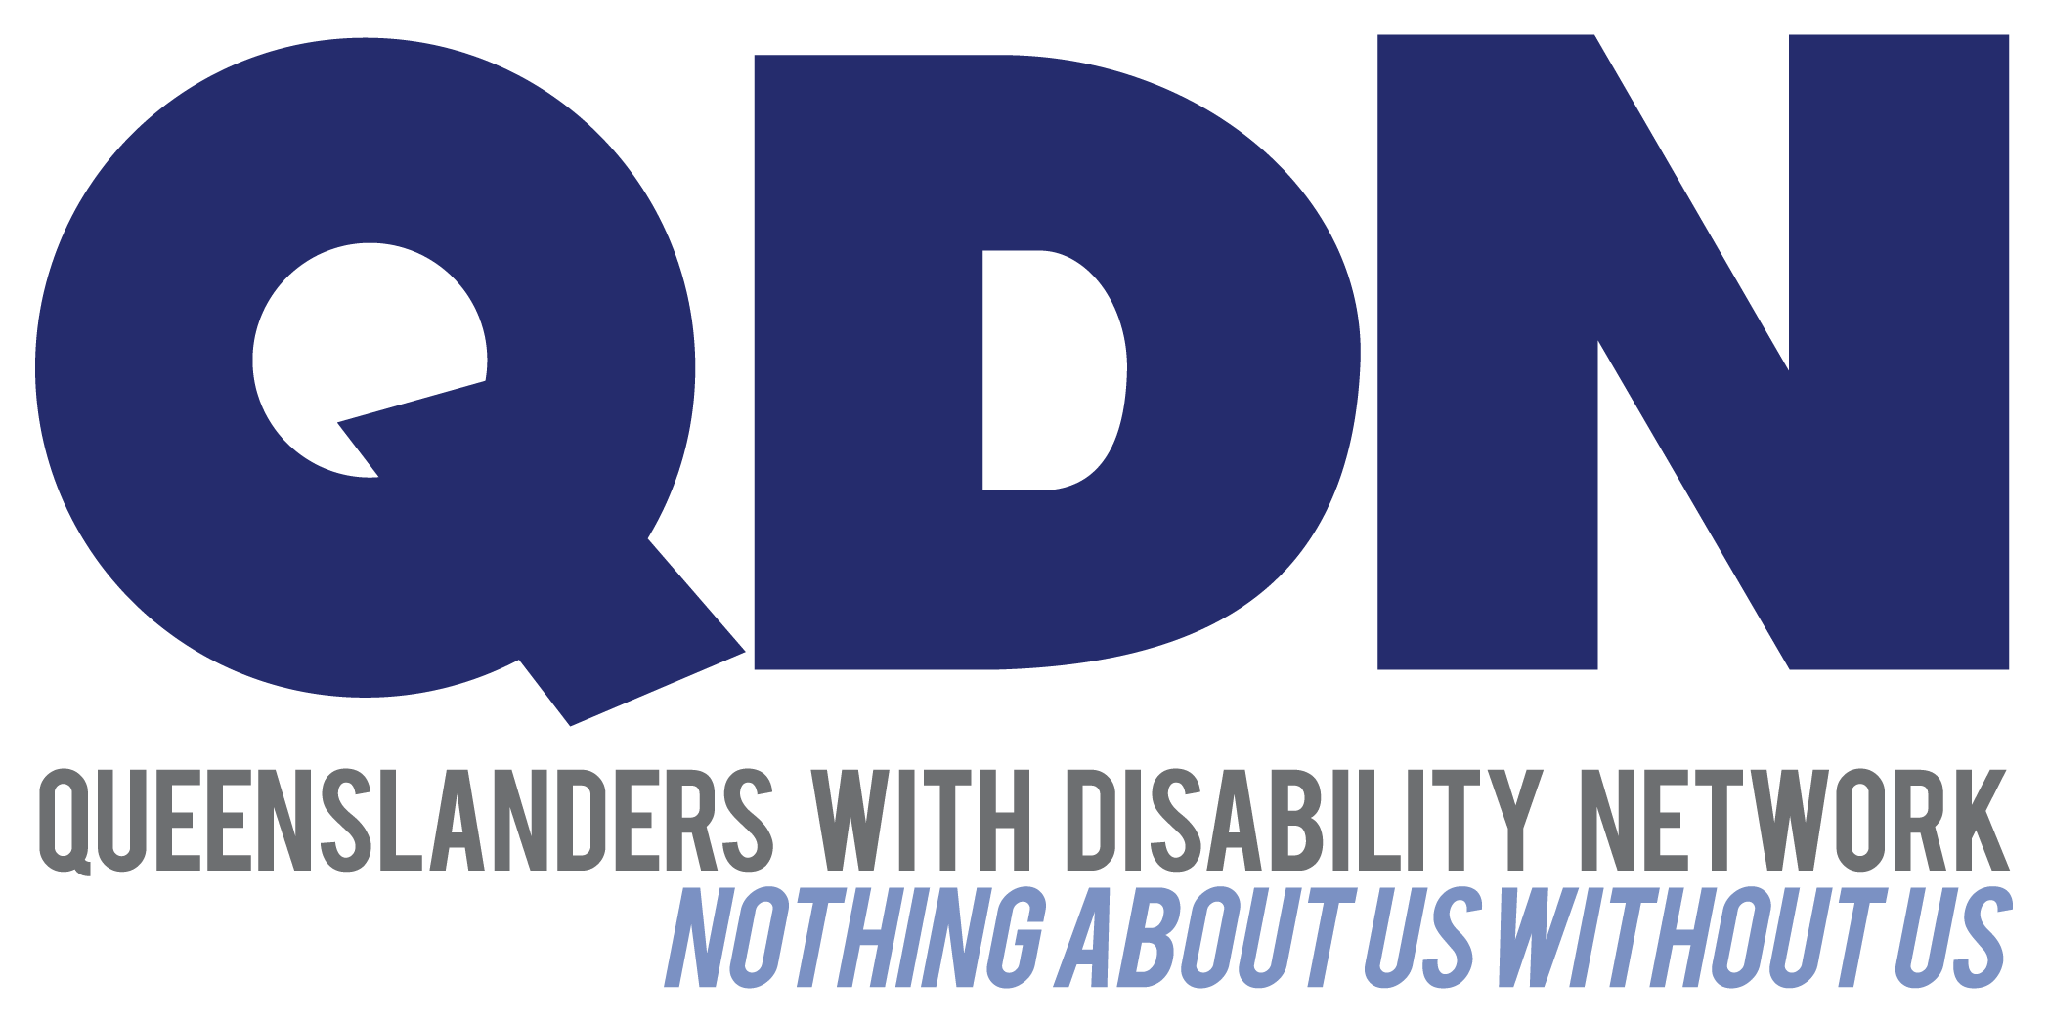

User-Friendly Version

Game Changers: Making sure everyone can get a job after the Brisbane 2032 Olympics and Paralympics

In this user-friendly document, important words are in bold and explained at the end.

Short Summary
The Brisbane 2032 Olympics and Paralympics are a big chance for Queensland to show how accessible things can be to everyone.

We want to make sure that after the Games, there is a legacy that lasts a long time of including everyone.

We want the legacy to help people with disability get good jobs that last.
Here is what we know: 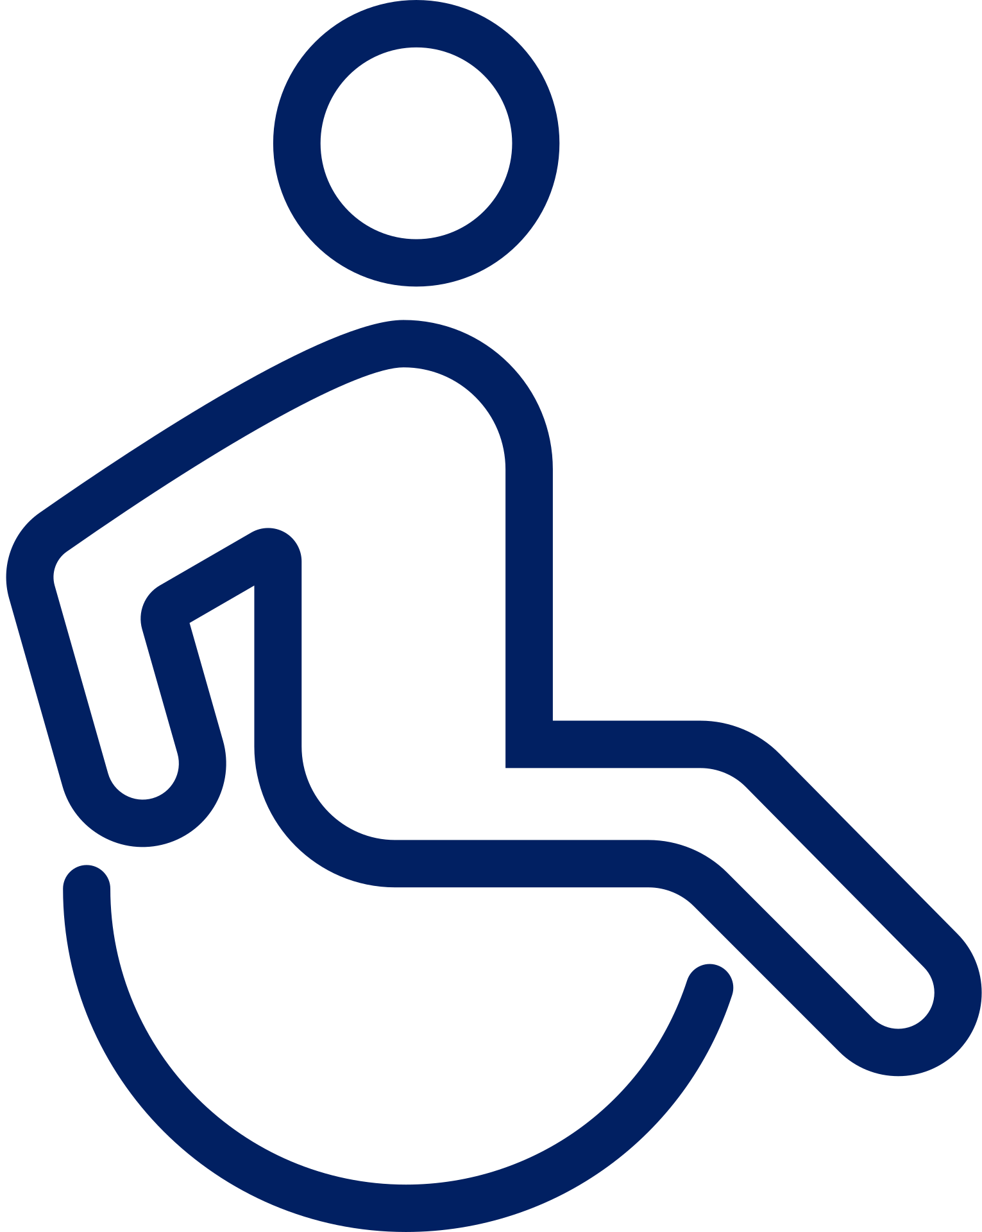
In Australia:
- one out of every five people has a disability, and
- they are twice as likely to not have a job.
People with disability usually work part-time but many are willing and able to work more.

There are obstacles to getting a job like:
- government rules and help
- how bosses think
- how well workers understand what they can do, and
- unfair beliefs.
Sometimes, people with disability start their own businesses to get around these obstacles.
Do we have rules about jobs? 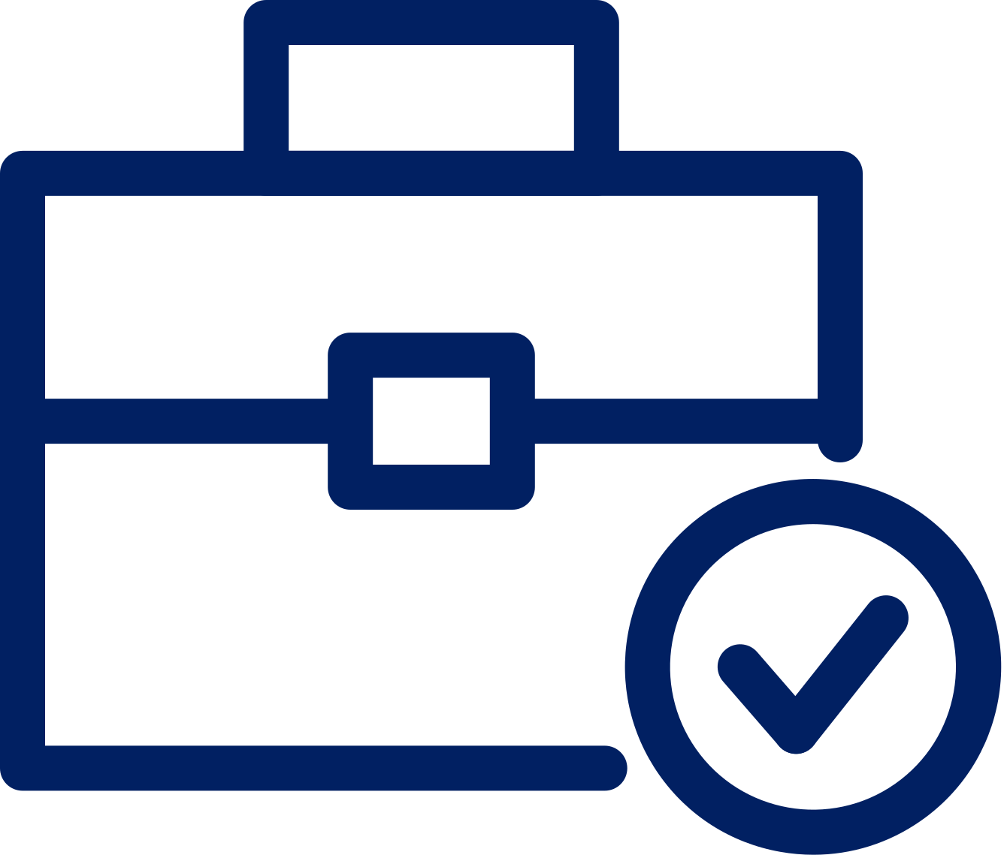
Disability job rules are complicated.

Reviews say we need big changes, but just having rules is not enough.

Setting goals for hiring people with disability can help but we need more help to make it work.

Some new plans for disability employment seem good and could make a big difference if we use them more.

We need to change how everyone thinks and everyone involved in jobs needs to work together to make sure everyone can work.
Can big events really make a difference? 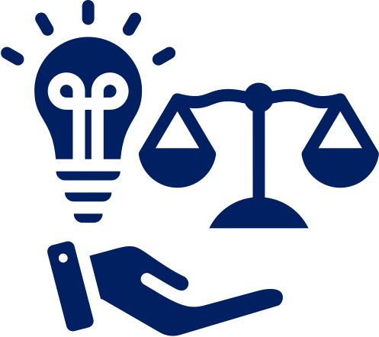
Looking at five events gives us important lessons:
The London 2012 Olympics and Paralympics were the first to focus on leaving a lasting impact. They offered job and training programs to promote equality and diversity.
The Gold Coast 2018 Commonwealth Games made things easier to access for everyone, but showed how important it is to connect different parts of the city so everyone can get around easily.
The Tokyo 2020 Olympics and Paralympics encouraged lots of people to volunteer, which could help more people get jobs in the future.
The FIFA 2023 Women’s World Cup showed how having more women's sports events can change attitudes and make things more inclusive.
Plans for the Paris 2024 Summer Olympics and Paralympics want to make things fairer and help more people get jobs. But they need to talk with people with disability to make sure they keep their promises and do not leave anyone out.
What is the chance we have? 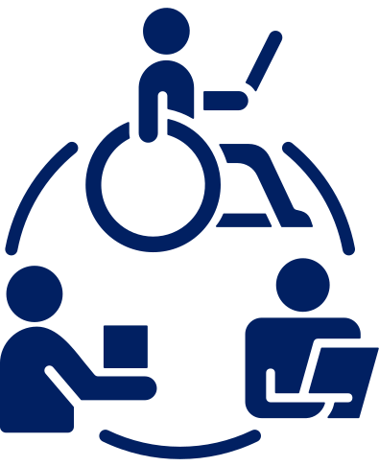
Having a good job is important.
It helps people:
- live better
- feel happier, and
- it is good for the whole community.

The 2032 Games gives us a big chance to change how jobs work with help from Indigenous people and people with disability.
This plan is called Elevate 2042.
It shows how we can use the Games to make sure everyone can get a good job and make:
- Queensland,
- Australia, and
- Oceania more inclusive.
This paper talks about jobs for people with disability in Queensland and gives ideas on how to make things better during the Games and after they are over.

The Problem

- 4.4 million Australians have a disability. Many of them struggle to find jobs.
- Disability job rules are complicated. We need big changes, not just rules.
- Goals for hiring people with disability are good, but they need more help to make them work.
- There are services to help people with disability find jobs, but they could be better.
- Some new plans from the government to help people with disability find jobs seem good. There are also other good ideas we can learn from.
- Even with all these rules and services, people with disability still find it hard to get jobs. We need to change how everyone thinks about this, and everyone involved in jobs needs to work together to fix the problem.
This report talks about how well people with disability are included in jobs in Queensland and Australia right now.
It also looks at how the plans for the 2032 Games are coming along and checks out what happened after big events like this in other places in the world.

4.4 million Australians have a disability.
More people with disability do not have jobs.
And some people with disability have jobs, but they do not work as much as they would like…
...but more people with disability work for themselves than people without disability.
Many people with disability start their own businesses to get around the problems of finding a job or not being happy with the jobs they can find.
But we do not know a lot about entrepreneurs with a disability in Australia or other places.
The latest studies about making things fairer for people with disability have shown that they face unfair treatment and are not getting enough jobs.

Reviews have shown that big changes are needed.
Just changing the rules will not make a big difference.
It is important to have goals for employing people with disability.
But these goals need help to happen.
Like
- Hiring a diverse group of people,
- Working with groups that help people find jobs to make more flexible work options,
- Making new rules for how we hire people and giving out helpful tools.

Disability Employment Services could give more help to support people with disability in finding and keeping jobs.
This might mean:
- finding jobs that people with disability actually want,
- understanding their skills more, and
- helping them succeed more often.

Recent government actions to help people with disability find jobs are making progress.

These actions are important for putting plans into action to help more people with disability get jobs.
Some of the biggest employers in Australia and Queensland are involved in these actions.
We are looking at three important programs led or funded by the government:
- IncludeAbility,
- All Abilities Job Match, and
- Career Pathways Pilot.

We are also looking at three programs led by private companies:
- Workability Queensland,
- Australian Spatial Analytics, and
- the Endeavour Foundation.
We are studying these programs to learn important lessons for getting and keeping jobs for people with disability.

AND THERE ARE ALSO SOME OTHER GOOD EXAMPLES

NDIS Training and Skills Support Strategy (NTSSS)
The NDIS Training and Skills Support Strategy (NTSSS) was a plan created by people in the industry, not the government.
It aimed to help more people in Queensland become part of the NDIS workforce by giving them the right training and skills.

All Abilities JobMatch
Queenslanders with Disability Network worked with Life Without Barriers and uLaunch to create the All Abilities JobMatch project.
This project is funded by the Department of Social Services until June 2024
It aims to help more employers in community services hire people with disability for all kinds of jobs within their organisation.

Career Pathways Pilot 2023 – 2025
The Business Council of Australia and the Australian Disability Network teamed up with the Australian Government to start the Career Pathways Pilot.
This happened because of a summit about jobs and skills held by the State Government in September 2022.

Australian Spatial Analytics (ASA)
ASA employs over 120 people, and 80% of them have a disability, mostly they are neurodiverse.
ASA sees the advantages of hiring people with disability and appreciates the skills and qualities that neurodiverse individuals bring to industries like geospatial and digital engineering.
These skills include recognising patterns, staying focused, solving problems, and being loyal.
But these examples still have room to grow.
Even with all these
- policies,
- services, and
- initiatives in place,
people with disability still face many obstacles in finding work.
There needs to be a change in the way people think...
88% of people with disability do not need any special changes to work.
They just need employers to see the value in hiring them.
Creating Legacy 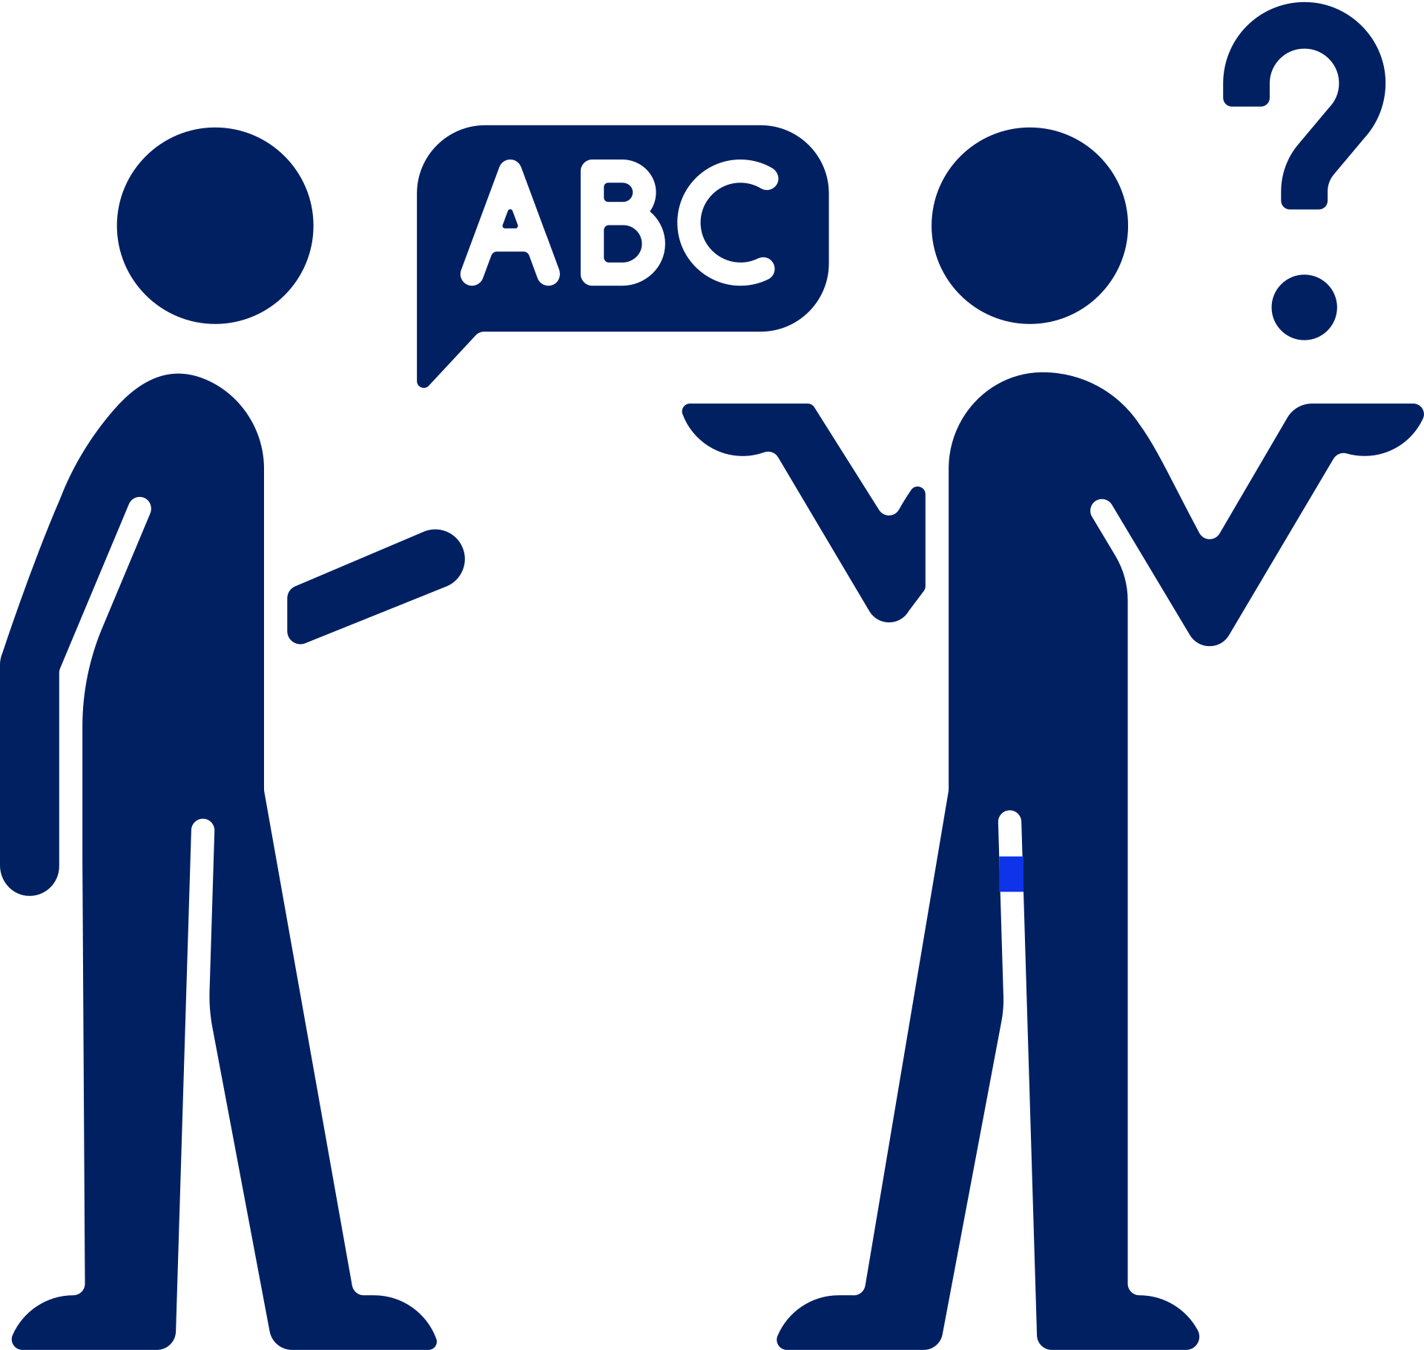

Making things easier for people with disability is a big part of this strategy.

It wants to see more people with disability at work and running their own businesses.

But, there are still some gaps in how this will happen.

We need more plans to train and support people with disability at work.

Buying Stuff in Queensland

The government has rules about how they buy things, called procurement.
Two important strategies,
- the Queensland Procurement Strategy 2023 and
- the Queensland Procurement Policy 2023,
help the government decide who they buy from.
These strategies aim to support local businesses and create jobs for people in Queensland.
But, when it comes to people with disability, these strategies do not say much about how to include them.
There are no specific targets or plans to make sure people with disability get a fair chance at work.

Main Industries to Focus on for Testing to Make Use of the Games' Positive Impact 

The Games will bring big changes, especially in industries like:
- media,
- sports,
- technology, and
- tourism.
These changes could create new jobs for people with disability.
But we need to make sure these jobs are accessible to everyone.
That means making sure workplaces are easy to get to and understand.
It also means changing how people think about disability so everyone feels welcome at work.

VISIONS FOR BRISBANE 2032 OLYMPIC AND PARALYMPIC GAMES LEGACY
GO FOR GOLD: A SOCIAL INCLUSION LEGACY FOR THE 2032 OLYMPIC & PARALYMPIC GAMES
The report suggests making sure more people who are unemployed or underemployed get jobs.
It is important that people can get to their job easily from where they live.

QDN ONLINE FORUM: BRISBANE 2032 GAMES VISIONING

On June 13th, 2022, QDN hosted the Brisbane 2032 Games Visioning Forum, with over 70 participants. It was opened by Hon Stirling Hinchliffe MP, Minister for Tourism, Innovation and Sport and Minister Assisting the Premier on Olympics and Paralympics Sport and Engagement. After the forum, a summary report was published.
Key things discussed at the forum included working together with people with disability, changing community attitudes, and making sure everyone feels included.

Recommendations
We have three main ideas to help fix the problem:
- First, get ready.
- Second, set goals.
- Third, make changes that last. It is really important that people with disability are in charge and help plan everything, from making the rules to putting them into action, and checking if they work.

PLAN TO SUCCESS
By 2028, we want to make sure things are ready to help people with disability get jobs during the Games.
1.1 Make sure people with disability are part of making decisions.
1.2 Create a group to make sure we reach our goals for hiring people with disability. This group will make sure
- the goals are right,
- we stick to them,
- and check if we meet them.
1.3 Make a plan for hiring people with disability and getting volunteers with disability for the Games.
1.4 Make programs to help people with disability get jobs in important areas.
1.5 Make rules that say a certain amount of money from buying things for the Games has to go to businesses that hire people with disability.
1.6 Make better services to help young people with disability find jobs when they finish school.
1.7 Make services better for people with disability who run their own businesses or want to start one.
1.8 Have a meeting before the Games to start planning what we want to leave behind.
1.9 Choose people who are good at including people with disability in their businesses and help them.
1.10 Teach businesses about including people with disability.
1.11 Make sure people with disability are part of collecting and checking data about jobs.

2. RAISING THE STANDARDS
By 2032, the Games have made clear goals and reached them for:
hiring people with disability,
buying from businesses that support disability, and
getting volunteers with disability.
2.1 Make sure everyone can easily enjoy the Games' buildings and spaces.
2.2 Decide how many people with disability we want to hire in important areas.
2.3 Make rules for how businesses should include people with disability in their workplaces.
2.4 Teach people about including people with disability through the media.
2.5 Give enough money to make all these plans happen.
Make sure being inclusive is part of everything we do to plan for the future.

3. THE FUTURE
By 2042, people with disability have more chances to get good jobs in a supportive work system.
3.1 Have a meeting after the Games to see what worked and plan for the future.
3.2 Make rules that say big companies have to hire people with disability.
3.3 Keep learning and use what we learn to make things better in businesses.
3.4 Change the program that helps people with disability find jobs.
3.5 Make sure we keep using what we learn to make things better in everyday business.

Important words

Access: Get to, reach or use.
Complicated: Difficult or hard to understand.
Data: Information.
Diversity: Having different kinds of people.
Equality: Fairness or treating everyone the same.
FIFA 2023 Women’s World Cup: The big women's football competition in 2023.
Legacy: Something important that we leave behind for the future.
Government: Elected people in charge and people employed to work in government.
Implementation Plan: plan to make things happen.
Inclusive: For everyone or including everyone.
Neurodiverse: people with diverse ways of thinking.
Obstacles: Challenges or problems.
Promote: Encourage or support.
Recommendations: Suggestions
Reviews: Checking or looking into something.
Volunteer: Help or work for free.

