Submission: Access to the NDIS

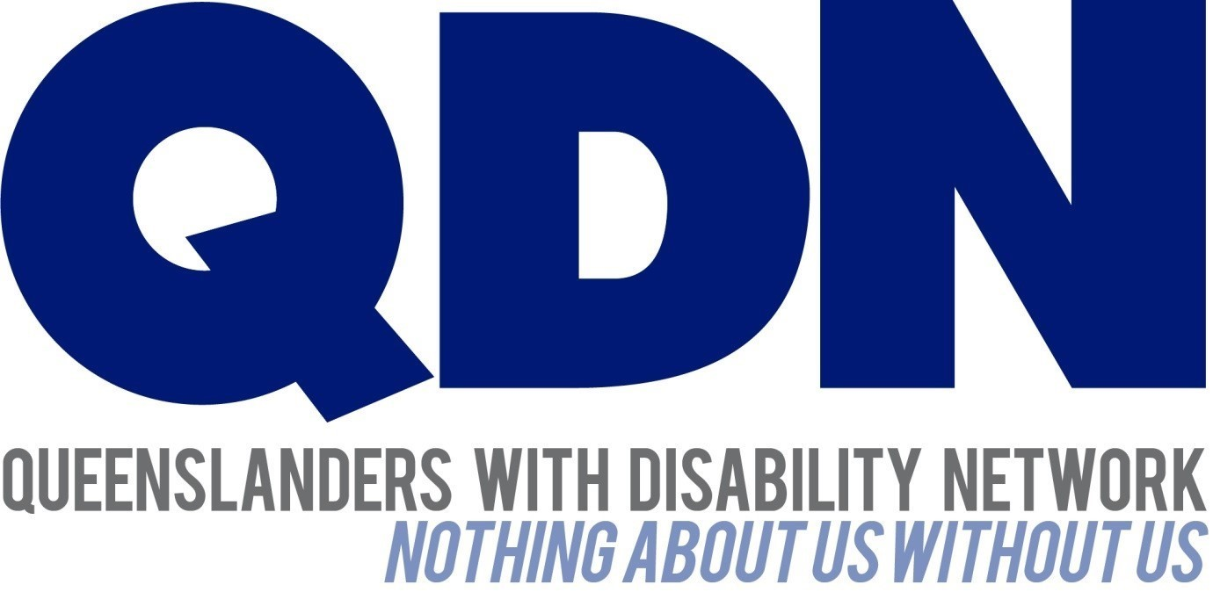

Submitted to the NDIS Review June 2023

About Queenslanders with Disability Network (QDN)
Queenslanders with Disability Network (QDN) is an organisation of, for, and with people with disability. The organisation’s motto is “nothing about us without us.” QDN operates a state-wide network of over 2,000 members and supporters who provide information, feedback, and views from a consumer perspective to inform systemic disability policy and disability advocacy.

QDN value statement
QDN believes that:
- All people with disability have a right to a place in the community and have contributions to make to community. This is as empowered, free citizens who are as valued, present, participating and welcomed as members of any dynamic and diverse society.
- The place of people with disability in the community is not just about people with disability having a house in the community. Core to this is that they are welcomed in the community as ordinary citizens where they are genuinely given opportunities to contribute and actively participate. People with disability need to be in communities where their individuality, their talents, and their lived experiences of disability are recognised and acknowledged.
- Culturally and historically, people with disability are not afforded the same value, opportunities or access to community life.
- Any inclusion in community for people with disability is conditional and vulnerable to withdrawal.
- Many people with disability in Queensland are excluded from the most basic experiences of ordinary lives.
- Current exclusionary practices are unacceptable and must be challenged.
- These issues affect not only people with disability but the whole community.
- The responsibility is shared. It lies within government (federal, state, and local) and the community at large, to ensure that people with disability have a place and are resourced to belong in community.

Introduction
Queenslanders with Disability Network (QDN) welcomes the opportunity to provide feedback to the NDIS review to ensure that the National Disability Insurance Scheme (NDIS) provides access to critical supports for people with disability to enable them to participate fully in an ‘ordinary life’, with choice, control and independence. For over 120 000 Queenslanders with disability, the NDIS has delivered critical access to services and support, many of them for the very first time as new participants. While QDN acknowledges the positive impacts the NDIS has brought for many people, there is also a need for overall improvement of the processes and structure of the NDIS for people with disability as end users of the scheme. Many Queenslanders with disability continue to experience significant barriers to access the scheme. There are even more access barriers for people with disability who identify as Aboriginal and Torres Strait Islander, Culturally and Linguistically Diverse, identify as LGBTQIA+.
The NDIS services 573,342 participants across the country. As of July 2022, there were 4.4 million people with disability in Australia. These statistics highlight a significant gap in the number of people with disability who may be eligible for the NDIS but currently aren’t receiving support from the scheme.

QDN and Access to the NDIS
QDN has been advocating, informing and preparing people with disability and the broader service system for the NDIS since the first vision emerged, Every Australian Counts Campaign and the Productivity Commission Report. Since 2015, QDN has successfully delivered eight specific projects, funded through Queensland and Commonwealth governments, related to NDIS readiness and transition. These have included state-wide projects, working closely with people with disability and their families, key government, community, and tertiary institution stakeholders. Through this work, informed and co-designed by people with disability, QDN has worked with over 22,000 people with disability. Five of these projects have had a specific focus on Access to the NDIS, four of these are outlined below and include:
- NDIS Participant Readiness - Ready to go project.
  - This project had a State-wide reach targeting people with intellectual and learning disability and families with members with impaired decision making. Its focus was supporting people to get ready for the NDIS, as well as working with people living in Level 3 supported accommodation facilities. It generated 570 activities across the state, reaching over 11,000 people.
- NDIS Participant Readiness work – rural and remote
  - 17 Rural and Remote Queensland Communities targeting People with disability, their families, community and disability organisations and Local Government Authorities. Engagement with 241 community, disability and government organisations working to build the capacity of participants, including a total of 221 participants.
- Getting on the NDIS Grid project
  - Engaging with ‘hard to reach’ cohorts in the south-east corner of the state, including people with disability who are transient, homeless, living in caravan parks, hostels, boarding houses, and social housing, accessing neighbourhood centre services and people with disability exiting the Child Safety, Juvenile Justice, and Criminal Justice service systems. This project engaged with over 7,600 individuals and organisations - 3,937 people with disability - 3,670 community, mainstream and faith-based groups, staff, and volunteers; held 500 formal events; developed creative resources to engage people with disability about the NDIS and assist their understanding about ‘What’s in it for them’.
    - developed a Patient Information Booklet and General Practitioner Toolkit to assist people with disability and GP and allied health professionals complete the access request form.
- Peer to Peer Advocacy project
  - People with disability in southeast Queensland wanting to access the NDIS and/or requiring support to confidentially engage in their preplanning and formal NDIS Plan meetings. This project worked with 1,400 people with disability.
At the end of the initial transition periods in Queensland, our state only had 50% of the projected estimated participants as part of the bilateral agreement in the scheme – 45,000. This equated to mainly legacy participants who were already connected to or engaged in the formal state based disability support system who had transferred over. QDN identified that there were significant gaps in the approach and way engagement was occurring through the established frameworks of NDIA and Partners in the Community that were not meeting the needs for people eligible for the scheme to navigate and undertake their NDIS access journey. QDN’s advocacy and learnings from these four projects resulted in QDN receiving funding for the Targeted Outreach Project with the model outlined below in more detail and the one that QDN identifies as the most appropriate approach and elements to deliver what is needed for people with disability and their families within this cohort to be able to access the NDIS with the right supports, models and structures to deliver better outcomes.

Targeted Outreach Project
As the NDIS rolled out in Queensland it became evident that many people who were eligible for the scheme were not accessing it, particularly those that are traditionally ‘hard to reach’ or had additional barriers. In response to this issue, a key project delivered in partnership with the (then) Queensland government Department of Seniors, Disability Services and Aboriginal Torres Strait Islander Partnerships (DSDSATSIP) was the Targeted Outreach Project (TOP). This project worked with the Queensland state government Assessment and Referral Team (ART) to engage with ‘hard to reach’ and marginalised people to support eligible people with disability to access to the scheme.
The Targeted Outreach Project worked intensely from early 2020 to the end of June 2022 (through COVID-19), with 2243 people with disability with regards to their NDIS eligibility resulting in 1284 (630 access approved, 544 of these individuals with plans) individuals with disability making direct referrals to ART. An additional 959 people who were not eligible for the NDIS were referred to other support systems (e.g. Queensland Community Support Scheme). TOP coordinated 2472 engagement/capacity activities and worked with 8608 individuals across the social service sector. TOP engaged with 4500 organisations, hosted 14 Local Level Engagement Groups (LLEG), with 241 organisations participating and contributing to regular LLEG meetings held in each region. TOP engaged 21 Local Champions with disability and lived experience of the NDIS across the regions as part of the project delivery. Additional detail can be found in relation to TOP outcomes through the final evaluation report at Appendix 1.
The role of QDN in engaging and providing initial support to vulnerable cohorts ceased on June 30, 2022, however the ART has continued to support people between the ages of 7-25. This support is much needed, however QDN recommends continued funding for access support and plan implementation through a similar model to ensure people with complex needs have the supports that they need.
While delivering essential individual support for people to access the NDIS through the TOP project, QDN was able to identify a range of systemic issues and challenges that prevented people from gaining access to the supports they needed. QDN has continued to raise the issues and impacts of the access process, especially upon people with disability who are marginalised and interact with several different complex systems through this project.
“Hard to reach” and vulnerable cohorts include rural, regional, and remote communities; Aboriginal and Torres Strait Islander people; people from culturally and linguistically diverse backgrounds; school leavers; adult prisoners; children in youth detention; children attending special school; and adults on community service orders. Engaging with this cohort includes a focus on people with disability in caravan parks, supported accommodation, social housing, and transient and homeless people.

Key systemic issues
QDN recognizes the need for systemic reforms to the National Disability Insurance Scheme and fundamental to informing these reforms is the authentic consultation and meaningful engagement of people with disability, their families, providers and the broader sector. QDN has undertaken a range of policy forums with members, both face to face and through online engagement to ensure our feedback to the NDIS review panel is also informed by lived experience. These issues are outlined below along with recommendations for change.

Mainstream services and system integration
- Local Area Coordinators (LAC)/NDIA Partners do not have the resources, skills, staff, and capacity to provide the level of assistance that people with complex and intersecting needs require to access the NDIS.
- Lack of understanding from health professionals (GP’s, specialists etc.) on what is required in an access request and are either not completing forms correctly, or do not understand their role and refusing to complete.
- The Child Safety system in some circumstances is using access to the NDIS for individuals as a compliance mechanism for children in out of home care. Access to the NDIS is an identified goal to have children returned to parent/care givers, whether the parent wants to receive NDIS or not. This has the additional impact of contributing to negative perceptions of NDIS support.
- Lack of clarity about who is eligible for NDIS with people with health conditions being given information by health professionals and workers in community services that they can access the NDIS when they do not fit eligibility criteria.
- Level 3 supported accommodation many people living in these facilities are long-term residents diagnosed with a psychosocial disability that is untreated or secondary to a more impactful impairment that likely does not meet the disability requirements for NDIS eligibility (e.g., substance use disorder, chronic pain). Continued work is needed to understand the support requirements of people living in these facilities, and others with psychosocial disability more who are disengaged from systems more broadly.

NDIS Access process
- The lack of affordability and lengthy wait periods for people needing to have assessments, diagnoses and/or treatments significantly disadvantages people from vulnerable cohorts trying to get access to the NDIS.
- People with disability in regional areas with limited access to health services have been refused by GPs to complete an access form if they have previously been refused access to the NDIS. This speaks to broader misconceptions and lack of knowledge about NDIS processes in the mainstream health system.
- People with disability without stable housing face further disadvantage throughout the NDIS access process. Their priority focus tends to be on their immediate housing crisis rather than the access process, which can provide lifetime supports.
- Lack of digital access and literacy – many people with disability can’t afford access to technology and also don’t have access to digital literacy support which could enable them to interact with the NDIS online interfaces.
- Lack of understanding of a diverse range of disabilities and consistency from NDIS staff – this is both in the sense of a lack of consistency of staff members and messaging which can give people conflicting information about eligibility as well as a lack of understanding of a diverse range of disabilities contributing to people falling through the cracks.
- Lack of trust in the NDIS when people have had negative experiences with staff or previous disability support systems, which may prevent them from applying (reinforced by some agencies such as Child Safety).

NDIS Plan Activation and implementation
- Plan development and plan management – there is a significant gap for vulnerable people who have been successful in gaining access to the NDIS in assistance in the development of individual support plans and planning review processes. This is evident through data which indicates the lack of implementation of NDIS plans. This is enhanced in regional, rural, and remote areas, particularly in Aboriginal and Torres Strait Islander communities with a lack of services and culturally respectful services.

People not eligible for the NDIS
- There is little practical support available for people without permanent disabilities who require functional support (health conditions, waiting for specialist appointments for assessments).
- There are large numbers of people experiencing homelessness with a psychosocial disability, however many are not eligible for NDIS due to their lack of engagement in treatment options despite experiencing significant functional impact of impairment.
- There is a specific need for information about other supports available in community, for people not eligible for a NDIS support plan. This was an intended role for LACs that has not been delivered and the impact of this gap means that people with disability not eligible for NDIS are not getting the supports they need.
- People from Culturally and Linguistically Diverse (CALD) backgrounds require significantly more targeted, relational, and intensive culturally appropriate support to ensure access to the NDIS, and ongoing attention to support them through processes.
- There is a lack of culturally appropriate services (Aboriginal and Torres Strait Islander and Culturally and Linguistically Diverse), particularly in rural and remote areas, which is impacting on people’s choice and control in relation to supports and deterring them from applying for access to the NDIS. In these communities, additional time is required to build relationships, a sense of safety and trust.

Recommendations

The NDIS system and people who are considered ‘hard to reach’ cohort.
- Targeted Outreach: The NDIS system includes a specific model of pre-access engagement and support for this cohort which is based upon the Queensland model outlined in Appendix 1 which includes Targeted Outreach Project and Access and Referral Team (ART). The model for adequate and appropriate NDIS access support needs to provide targeted, tailored and place-based engagement to deliver outreach to potential NDIS eligible people with disability. This needs to include engagement, providing information and connection with both mainstream and community services about the NDIS, how to identify clients that would be eligible for the NDIS, and clear pathways of referral and support for access requests. The model also needs to include engagement and employment of people with disability, with lived experience of the NDIS to provide peer support, share information about the benefits and types of disability supports it can provide for people. Please refer to the QDN Targeted Outreach project evaluation report at Appendix 1 for more information on a tested model.
- This cohort needs ongoing supports beyond the access process. Once access has been approved for many recipients with complex needs, they need specialised support to ensure that plans are activated to their potential and an ongoing case management to support with any issues and safeguard the delivery of supports and navigate the complex environments.
- This cohort needs ongoing pathways for referrals to access to free allied health practitioners for assessments and diagnosis and to access a range of support programs (including NDIS).

Mainstream Services and system integration
- Coordination role – fund a coordination role at a regional level to identify and develop clear pathways and deliver integrated services across Government agencies and the NDIS. This will ensure the delivery of streamlined access pathways, smooth transitions between systems with appropriate housing options, timely NDIS plans, and appropriate support for plan activation and plan implementation.
- Deliver workforce training, capacity building and resourcing for government and mainstream service professionals on NDIS access, eligibility guidelines, pathways, and other available programs of disability support. This training needs to be co-designed and delivered by people with disability.

NDIS Access Process
- Expand the level of support provided to people within this cohort through targeted outreach programs (like TOP) to include ‘hands on support’ for system navigation to ensure they can action referrals and support, including support for GPs.

Community and disability providers
- Targeted outreach to deliver information and awareness raising about the NDIS and access, eligibility requirements for community organisations to build their capacity to identify and support eligible people to link with appropriate pathway/services. Building the capacity of community organisations to undertake this work requires additional resourcing for workers.
- Increased disability-informed practice training for call-centre staff and Local Area Coordinators and more clarity around the responsibilities of each of these roles.
- More information sharing and transparency about how access decisions are made as well as clearly explaining the reasons behind the rejection of NDIS applications to potential participants and what they would need to be successful in their application.
- Ensuring people with disability can have direct communication with decision-makers, along with more consistency in messaging around access and eligibility by NDIS staff.

Digital Inclusion and digital access
- Through QDN’s work in Digital Inclusion, it is critical that alongside targeted approaches to support NDIS access, a focus is given to include the digital literacy, capacity and access to technology for people with disability. This is important not only at the access phase, but for people once they are participants in the scheme.

Appendix 1.
Targeted Outreach Project
Evaluation and Final Report

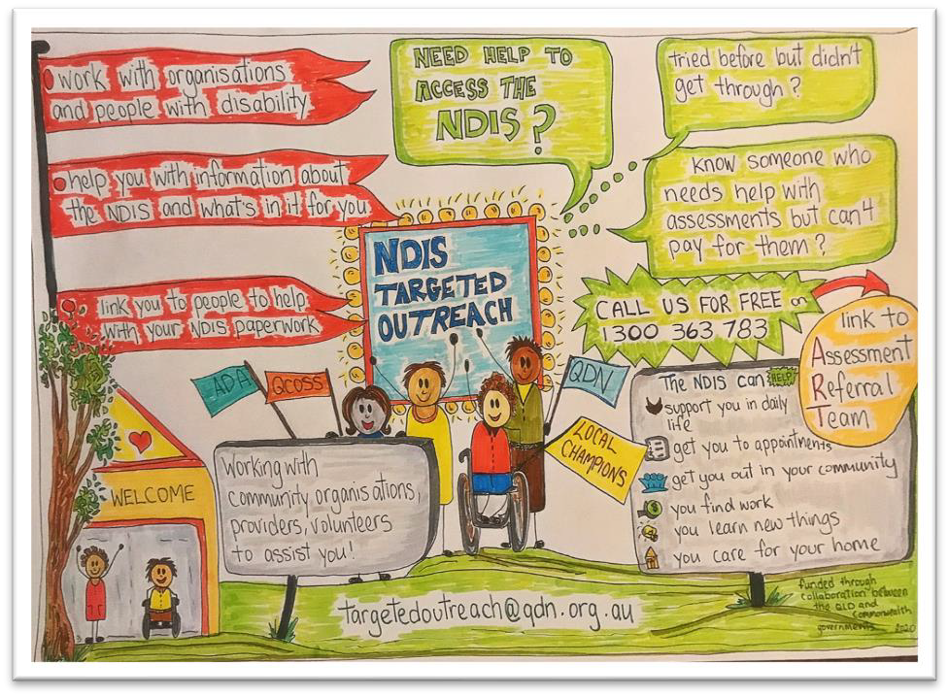

June 2022

Table of Contents
Executive Summary 3
Key outcomes 3
The model 4
Identified issues 5
Recommendation for future support 9
Impact of COVID-19 and natural disasters 11
Introduction 12
Evaluation 13
Methodology 13
Key findings 13
Survey outcomes 32
Program approach and impact 40
Final evaluation conclusions 40
Appendix A – Case studies from evaluation 42
Appendix B – Project Service Particulars Achievement 44
Appendix C – Documents Reviewed 46

Executive Summary
The Targeted Outreach Project (TOP), delivered by Queenslanders with Disability Network (QDN) in partnership with Queensland Council of Social Services (QCOSS), AMPARO Advocacy and Aged and Disability Advocacy Australia (ADA), focused on ensuring that hard-to-reach, marginalised and/or vulnerable people with disability are identified, informed, and supported to access the National Disability Insurance Scheme (NDIS). An investment of $2,350,000 (excl. GST) was provided through the Department of Seniors, Disability Services and Aboriginal and Torres Strait Islander Partnerships’ (DSDSATSIP) Disability Connect and Outreach Program to design and deliver services across 13 locations from February 2020 to 30 June 2022.

Key outcomes
TOP worked intensely with 2243 people with disability with regards to their NDIS eligibility resulting in 1284 (630 access approved, 544 of these individuals with plans) individuals with disability making direct referrals to ART. An additional 959 people were referred to other support systems (e.g. Queensland Community Support Scheme). These figures do not reflect the referrals generated through QDN’s direct engagement with organisations about the project who made their own contact with ART on behalf or with their clients to access the services and supports.
TOP coordinated 2472 engagement/capacity activities and worked with 8608 individuals across the social service sector. TOP engaged with 4500 organisations, hosted 14 Local Level Engagement Groups (LLEG), with 241 organisations participating and contributing to regular LLEG meetings held in each region. TOP engaged 21 Local Champions with disability and lived experience of the NDIS across the regions as part of the project delivery.
Building the capacity of organisations to make their own referrals to ART was a key outcome of engagement activities, however this data about source of referral to ART was not recorded by Department to capture the number of referrals made by organisations directly to ART because of TOP engagement.
Table 1. Overview of key TOP outcomes
NDIS access support | Enquiries received | Eligible referrals progressed to Assessment and Referral Team (ART) | People referred to other support programs
NDIS access support | 2243 | 1284 | 959
Local leadership | Local Level Engagement Groups (LLEG) | Local Level Engagement Group Contributors | Local Champions
Local leadership | 14 | 241 | 21
Engagement and Capacity Building | Activities completed | Interactions with organisations | Interactions with individuals
Engagement and Capacity Building | 2731 | 5160 | 10,183

The model
TOP delivered an innovative approach of locally based engagement accompanied and individually tailored information, assistance, and support to people with disability to understand and navigate the NDIS access process.
This model included engagement and outreach by project staff and Local Champions with community organisations and services working with people with disability potentially eligible for NDIS and directly with people with disability themselves to:
- share information about the NDIS, eligibility, the benefits, and disability supports.
- provide links to pathways for referral to assist with access process and navigating the complex environment to connect with experienced workers at QDN to support individuals and or family/carers.
- provide information about pathway to Assessment and Referral Team (ART) to provide case-management for NDIS access including assessments.
The evaluation has shown the single most important success factor in TOP has been the strength of the iteratively developed local delivery model. QDN and consortia partners have co-designed an innovative, place-based, and person-centric model, that has leveraged off their extensive networks and locally based engagement experience. The key elements of the model have provided an integrated approach, that has built on learnings as the project has been implemented across regions, and adapted strategies to meet emerging need.
Key elements of the model include:
Employing people with disability as Local Champions
Local Champions are people employed in each region with lived experience of disability who are NDIS recipients that have strong local knowledge and networks and can assist in the connection and implementation of the program at a community level.
Local Level Engagement Groups
The Local Level Engagement Groups (LLEG) in each region were identified and convened by the project for invited key stakeholders including existing services, community leaders and local champions to work together to inform the best practice engagement model, locally designed by each community. These groups were leveraged from the strong community engagement, knowledge, and relationships that QDN and consortia partners had in communities across the state. Each local engagement plan was informed by and leveraged off existing networks, community practices, and knowledge of community members requiring support/access. This both provides a soft entry point for people already engaged with services needing access but also builds the capacity of organisations in understanding and navigating the NDIS systems.
Consortia model
QDN, QCOSS, ADA Australia, including the ATSIDNQ, and AMPARO Advocacy individually operate as State-wide organisations and have extensive state-wide reach, footprint, and established relationships. The organisational membership of the consortia organisations exceeds 4,000 members, and through databases, collective access to over 20,000 people with disability, carers, non-government and government providers, and voluntary organisations. TOP utilised the strengths in our partner organisations to further promote and action the project. This is particularly evident in the establishment of Local Champions, Local Level Engagement Groups and corresponding Actions Plans. This consortium therefore brings to this project additional state-wide networks and local service reach through the peaks. The organisations that sit under the peaks facilitate further project spread through access to membership of organisations and voluntary groups in local communities that align and link with the priority cohorts identified for this project.
Intake and assessment
Referral pathways included either an online form, or free call access number to QDN. People/supporters/services were then engaged with directly using a person-centred approach to undertake a functional impact assessment and systemic knowledge to understand people’s individual circumstances, whether they met eligibility requirements for referral to ART, or other referral pathways for support. For those people assessed as potentially meeting NDIS access requirements, TOP liaised with individuals, organisations, and health services to gather the information required prior to a referral to ART. For those people who did not meet eligibility requirements, QDN used a holistic wrap around service approach to ensure that everyone who contacted was supported either through information, alternate support options or referral to another organisation. Some individuals required advocacy around systems navigation to ensure a pathway was identified.
Community engagement
Community engagement through networks and local partners has been essential to the TOP model. Being in community to meet people where they are at physically and targeting a broad range of organisations who are working with people not necessarily engaged with disability services. Being adaptive in messaging to reach all people in a way they understand, and all layers of community.
Knowledge brokers
TOP has acted as an intermediary for relationships and networks by providing linkages, knowledge sources and information about services, supports, and expertise in relation to the NDIS, beyond just assessment and referral for individuals. This includes with organisations and services, but also around plan management and NDIS processes beyond access to the scheme. Some families/individuals are not sure if they want the NDIS, so ensuring they understand the parameters.
Capacity building
TOP provided individualised training and support around the NDIS and access requirements for organisations and services to build their knowledge base and skills to support people into the NDIS. This has been delivered through a range of mechanisms in response to community and organisational need.

Identified issues.
Whilst the project delivered outcomes for people with disability in their NDIS access process, the work also highlighted an ongoing range of broader systemic issues impacting upon people with disability, services, and the varying mainstream systems. It is critical that these issues are reviewed, and ongoing solutions and actions are put in place to address these. These issues have been raised through QDN quarterly reports however are summarised below:
Current NDIS system challenges and impacts for this ‘hard to reach’ cohort.
- Local Area Coordinators (LAC)/NDIA Partners do not have the resources, skills, staff, and capacity to provide the required level of assistance to support people within this cohort and complexity of needs to access the NDIS, resulting in this falling back on community sector organisations who identify that they lack knowledge of NDIS and resources to support people adequately. Many people experiencing complexity require ‘hands on’ support to gather required evidence. These issues are accentuated in regional, rural, and remote areas.
- Feedback was provided to the project about examples of people with disability being exploited by service providers as part of supporting individuals to get access to the NDIS. Situations were reported to the project where NDIS providers told individuals that they would help complete their NDIS access form, in return for a payment once they gain access, and a commitment to use that service provider to deliver services under their plan once approved.
“Need somewhere to refer complex cases to support them to access the NDIS. Better training to LACs to support them to understand access requirements. Need access to a service who understands and can support and navigate both the client complexities and the NDIS. Need intensive support to access documents to confirm their eligibility - gathering this information is costly, time consuming and stressful on individuals”.
(Service provider survey response)
Mainstream services and system integration
- There is still a lack of understanding from health professionals (GP’s, specialists etc) on what is required in an access request and are either not completing forms correctly, or do not understand their role and refusing to complete. NDIS access documentation is not covered as a billable item under Medicare, so GPs cannot charge patients for visits to do this solely, which reinforces some GPs reluctance to engage around the scheme.
- There is confusion around the roles and responsibilities in relation to access and support for people engaged in a range of government agencies including Child Protection, Juvenile Justice, Corrections, and the Hospital system which indicates broader systemic issues and a lack of understanding and integration of agencies working collaboratively to support people.
- The Child Safety system in some circumstances is using access to the NDIS for individuals as a compliance mechanism for children in out of home care. Access to the NDIS is an identified goal to have children returned to parent/care givers. This not only removes the principles of choice and control for individuals, but often people are not eligible, in addition to creating a negative perception of the NDIS and how people could potentially access long term needed support.
“The team were very knowledgeable and allocated the time I needed to focus on the information required through in-depth interviews. It took a lot of time and sometimes it felt very brutal trying to excise one chronic illness while evidencing another - from my point of view living with multiple related conditions, separating one from the other is pointless as they aren’t separate but reactive and work together to create an insurmountable challenge to daily living” (participants survey response).
NDIS Eligibility
- Lack of clarity about who is eligible for NDIS with people with health conditions being given information by health professionals and workers in community services that they can access the NDIS when they do not fit eligibility criteria.
- Level 3 supported accommodation many people living in these facilities are long-term residents diagnosed with a psychosocial disability that is untreated or secondary to a more impactful impairment that likely does not meet the disability requirements for NDIS eligibility (e.g., substance use disorder, chronic pain). Continued work is needed to understand the support requirements of people living in these facilities.
NDIS Access process
- The lack of affordability and lengthy wait periods for people needing to have assessments, diagnoses and/or treatments significantly disadvantages people from vulnerable cohorts trying to get access to the NDIS. This issue is ongoing, with ART meeting only a small percentage of the need across communities.
- Feedback was provided to the project about experiences of people with disability in regional areas where GPs refused to complete an access form if an individual has previously been refused access to the NDIS.
- People with disability without stable housing face further disadvantage throughout the NDIS access process. Their priority focus tends to be on their immediate housing crisis rather than the access process, which can provide lifetime supports.
“Better access to those who provide the necessary reports and assessments. trying to find allied health service providers with the capacity to provide these services is difficult however more frustrating is the level of price gouging. I was recently quoted 3000 for a client’s diagnosis and assessments. The people we deal with can’t afford to put food on their tables” (Service provider survey response).
NDIS Plan Activation and implementation
- Plan development and plan management – there is a significant gap for vulnerable people who have been successful in gaining access to the NDIS in assistance in the development of individual support plans. Currently people are not being supported to develop plans, although once a plan is developed, they can request additional funds for plan management. This results in either underutilisation of plans and funding withdrawn, or the plan not being implemented at all.
People not eligible for the NDIS
- There is little practical support available for people without permanent disabilities who require functional support (health conditions, waiting for specialist appointments for assessments). For these people, the only practical options are waiting to get better, waiting to get worse, or being eligible for four hours of QCSS support per fortnight (see Case study 1).
- There are large numbers of people experiencing homelessness with a psychosocial disability, however many are not eligible for NDIS due to their lack of engagement in treatment options despite experiencing significant functional impact of impairment. This issue is compounded by increasingly strict parameters for access to the NDIS for people with psychosocial disability. Housing and homelessness services have limited or no capacity, skills, or resources to support people to navigate these systems or collect evidence for a NDIS application/exhausting treatment option.
- There is a specific need for information about other supports available in community, for people not eligible for a NDIS support plan. This was an intended role for LACs that has not been delivered and the impact of this gap means that people with disability not eligible for NDIS are not getting the supports they need.
People in regional, and rural areas even if they are eligible for support through the Queensland Community Support Scheme (QCSS), there are no services to deliver support.
“The winding-up of this program will be sorely missed, especially for those with psycho-social disabilities who do not have the evidence and cannot obtain this without having to pay for expensive reports. The Qld Government should continue to fund professionals who can assist with the assessment needed to apply otherwise Queenslanders without support will continue to access acute services (i.e., mental health emergency) instead of long term supports” (Service provider survey response).
Cultural considerations
- People from Culturally and Linguistically Diverse (CALD) backgrounds require significantly more targeted, relational, and intensive culturally appropriate support to ensure access to the NDIS, and ongoing attention to support them through processes. Currently only 5.6% of NDIS Participants in Queensland are from a CALD background, significantly less than the expected figure of 12-15%.
- There is a lack of culturally appropriate services (Aboriginal and Torres Strait Islander and Culturally and Linguistically Diverse), particularly in rural and remote areas, which is impacting on people’s choice and control in relation to supports and deterring them from applying for access to the NDIS. In these communities, additional time is required to build relationships, a sense of safety and trust.
“It is hugely disappointing that the program has ceased, primarily as the people most in need of their support will have to find alternate, less effective pathways to attempt to access the scheme. Many of the most vulnerable who desperately need a program such as the TOP will never access the support they need” (Participant survey respondent).
Regional, rural, and remote impacts
- Individuals who reside in rural and remote areas are very limited in the support they have available even if they do get access to the NDIS. The NDIS price guide does not cover cost to deliver in many of these areas and discourages services from extending support into rural and remote areas.
- The lack of transport in rural and remote regions impacts on people’s capacity to attend appointments and receive support, with many requiring overnight accommodation resulting in significant financial impact on already disadvantaged Individuals.
“For families engaged with our service the process of completing NDIS applications is time consuming, costly, and challenging. A service that provides direct case management and informs parents of what is required every step of the way was extremely helpful as we could refer directly into the service. Due to being only a short-term referral service we are unable to support families ourselves through the NDIS process as it is timely and out of our scope” (Service provider survey response).
Community and disability providers
- There is still a lot of confusion in relation to what the NDIS is, the roles and responsibilities of different organisations (NDIA, NDIS, LAC, health professionals, disability service providers) and the access process. There is insufficient appropriate help available through mainstream channels to assist people with both information and access, so they are reaching out to other providers (e.g., community organisations) who lack the skills, knowledge, and training to provide appropriate help.
- Assisting people with NDIS access requests is outside the scope of most organisations, unfunded and often requires intensive case management support, particularly for people with psychosocial disability and for people also experiencing homelessness.

Recommendation for future support
With the completion of this project, there are currently no funded models or services that deliver the critical outreach and intensive case management support that TOP and ART have been able to offer vulnerable people across Queensland. It is evident that there is still substantial and ongoing need across communities, particularly in rural, regional, and remote areas for education, capacity building and support to access the NDIS. It is recommended that the TOP model be extended and expanded, building on the extensive relationships and work done over the two years of funding, to continue support for vulnerable Queenslanders with disability requiring support to access the NDIS.
Theme | Recommendation
The NDIS system and people who are considered ‘hard to reach’ cohort | The NDIS system includes a specific model of pre-access support and engagement for this cohort that provides.  - targeted, tailored and user- friendly engagement to deliver outreach to potential NDIS eligible people with disability and mainstream and community services about NDIS that includes engagement by people with disability with lived experience of the NDIS to share information, the benefits and the type of disability supports it can provide for people.  - pre-access support, information, and case management to assist with access process and navigating the complex environment.  - Pathways for referrals to access to free allied health practitioners for assessments and diagnosis for access to a range of support programs (including NDIS).
Mainstream Services and system integration | - Identify and develop clear pathways and deliver integrated services across Queensland Government agencies and NDIS to deliver streamlined access pathways, smooth transitions between systems with appropriate housing options, timely NDIS plans, and appropriate support for plan activation and plan implementation.  - Deliver workforce training, capacity building and resourcing for Queensland Government and mainstream service professionals on NDIS access, eligibility guidelines, pathways, and other available programs
NDIS Access Process | - expand the level of support provided to people within this cohort to include ‘hands on support’ for system navigation to ensure they can action referrals and support, including support for GPs
NDIS Plan activation and implementation | - For people with disability who are part of this cohort, additional support in relation to plan development is required once NDIS access has been approved. Many vulnerable people who require support in relation to gaining access to the NDIS, also require continued support to develop and implement plans. This needs to be addressed through Specialist Supports Coordination that is adequately funded and market capability for these specialist services is built to address this critical gap in services.
People not eligible for the NDIS | - Revised LAC models and contracts to include specific services and targets to link people with disability not eligible for NDIS within this cohort to appropriate community supports and services that go beyond provision of a phone number or website and includes hands on practical support.  - Queensland Government to work with Commonwealth Government to identify key gaps in services for people with disability not eligible for NDIS including people with chronic health conditions, people experiencing homelessness, people with psychosocial disability and develop a state-wide service model across community and mainstream services.  - Identify a strategic and targeted approach for tier 2 Information, Linkages and Capacity Building to deliver priority investment for key mainstream services supporting this cohort including health, housing, corrections, and justice systems.  - Workforce and market strategy needs to deliver outcomes including increased staff and services for people in regional, and rural areas eligible for support through Queensland community support scheme (QCSS)
Cultural considerations | - Targeted, trusted, on the ground, relational and intensive outreach, and engagement support for people from Culturally and Linguistically Diverse (CALD) backgrounds and Aboriginal and Torres Strait Islander backgrounds particularly in rural and remote areas to deliver improved choice and control in relation to supports and appropriate support to apply to access to the NDIS.
Regional, rural, and remote | - Targeted and innovative approaches for rural, regional, and remote communities to build participant capabilities, market, and services, with considerations and services built in to address lack of transport and significant geographical distances in western, north, and far north Queensland.
Community and disability providers | - Targeted outreach to deliver information and awareness raising about the NDIS and access, eligibility requirements for community organisations to build their capacity and resourcing for workers to identify and support eligible people to link with appropriate pathway/service.

Impact of COVID-19 and natural disasters
The project launched in early 2020 and was immediately impacted by the global COVID19 pandemic requiring an immediate shift in the model to virtual engagement for the regions in the first phase of delivery. The environment delayed both contractual implementation and delivery in the initial phase, resulting in reduced time to engage with some communities and a sense of ‘barely starting in some areas before ending’ (Source - Consortia and Local Champions). The project was also impacted by significant flooding events in regions in Southeast QLD.

Introduction
In March 2020, the Queenslanders Disability Network (QDN) was awarded one-off project funding of $2,350,000 (excl. GST) through the Department of Seniors, Disability Services and Aboriginal and Torres Strait Islander Partnerships (DSDSATSIP/Department). The funding provided under a Commonwealth/State government bilateral agreement was part of a Commonwealth Government strategic investment program aimed at increasing the number of Queenslanders participating in the National Disability Insurance Scheme (NDIS). The funding was provided until 30 June 2022.
The Targeted Outreach Project (TOP) was implemented in a time of significant global economic, political, health and social change following the COVID19 pandemic and natural disasters, and characterised by factors such as rising inflation, cost of living pressures, record low rental housing availability (public and private) and workforce shortages. In these unprecedented times, the necessity of providing ongoing support for vulnerable people to access the NDIS and to implement plans once approved, has never been more vital.
The purpose of the TOP was to undertake targeted outreach with people with disability, community, and mainstream services in communities across Queensland to identify, support and refer potentially eligible applicants to the Department’s Assessment and Referral teams (ART) from the priority cohorts below:
- Rural, regional, and remote communities
- People from culturally and linguistically diverse backgrounds
- Aboriginal and Torres Strait Islander people
- School leavers
- Adult prisoners
- Children in youth detention
- Children attending special school.
- Adults on community service orders
- Other (individuals and families at high risk of homelessness, domestic and family violence, hospitalisation)
In addition to this, significant work was conducted to build the capacity of community-based organisations to fully understand the eligibility criteria for NDIS access and what this may mean for their client base. With regards to this, the objective of the Targeted Outreach Project was to:
- Ensure people with disability, their families/carers and community organisations support them had information about the NDIS, what disability supports the NDIS can offer, eligibility and how the NDIS is changing lives.
- motivate people with disability, their families, and carers to make an access request to the NDIS, or make additional attempts at access, with the assistance of ART.
- increase awareness of ART and the free services it offers to help people gain access to the NDIS, specifically targeting potential participants who are in priority cohorts including hard-to-reach people and/or vulnerable community members.
- utilise multiple communication and engagement channels, ensuring culturally appropriate and accessible activities, including individual outreach, information sessions and other activities to provide information about the benefits of the ways ART can assist with scheme access, to potential participants who are considered hard-to-reach or vulnerable.
- encourage service providers, influencers, and organisations to refer people with disability to ART for assistance.
- ensure the roles of ART and QDN in the NDIS context are clear to stakeholders and potential participants.
- ensure communications strategies, content and marketing collateral assist project and engagement stakeholders and potential participants to understand the relationships between the project’s partners.
This work resulted in significant awareness raising of the ART component of the project, and organisations consequently could refer directly to ART for support.
The project was progressively implemented in four stages in the following geographic areas:
- Caboolture /Strathpine, Maroochydore, and Maryborough (Phase 1)
- Bundaberg, Rockhampton, Toowoomba, and Townsville (Phase 2)
- Cairns and Mackay (Phase 3), and
- Beenleigh, Ipswich, Brisbane, and Robina (Phase 4).
These locations aligned with DSDSATSIP’s establishment of ART, which worked alongside TOP to provide intensive case management, coordinate, and undertake assessment and NDIS access request documentation.

Evaluation
An evaluation of the Targeted Outreach Program has been undertaken by an independent consultant to understand the impact of the model, identify issues, and contribute learnings to any future iterations of support.

Methodology
The evaluation was conducted during April - May 2022 using a methodology which included:
- Revision of existing QDN quarterly reports provided to the Department.
- Quantitative data analysis of participant and referral numbers.
- The distribution of four surveys and the analysis of results.
- Local Champions
- Consortia and Project Teams
- Participants
- Referring organisations
- Local Champion focus group
- Individual Local Champion interviews (based on individual’s preference rather group process).
- Interviews with selected project team members.
- Final report and recommendations.

Key findings
Overview
Overall, the evaluation found the Targeted Outreach Project was a successful initiative, raising awareness of the NDIS with service providers, and identifying and referring ‘harder to reach’ people with a disability from the targeted cohorts to ART for intensive case management to secure NDIS access and a plan. This was achieved for 1284 people with a disability (630 access approved, 544 of these individuals as a result with plans).
Critically, the evaluation consistently demonstrated that outcomes from engagement activities are premised on trust and time. The importance of having local people with lived experience of the NDIS journey to build trust with potential NDIS applicants was an important element of the work. The features of local engagement groups and Local Champions playing an essential and significant role in the project’s success. The model builds on previous successful work by QDN related to NDIS readiness and transition and strong existing networks and relationships across communities by both QDN and consortia partners.
The model involves targeted place-based community engagement through Local Level Engagement Groups and Local Champions and direct outreach to meet people where they are at, to ensure as broader connection to vulnerable cohorts as possible. Referrals were received by individuals, services, family members/supporters and agencies. QDN undertook strength-based and person-centric assessment processes to ensure people were supported either into a referral to ART or linked to other supports in community.
The model is described in the diagram below in its basic form. The evaluation has highlighted the key issues experienced by people with disability across Queensland in relation to access of the NDIS and support, and any future model should incorporate those learnings and extend support to those most vulnerable (see recommendations).
Diagram 1. TOP Model
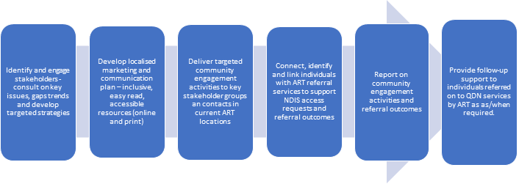
Intake and referral data
The following data is collated from QDN databases in relation to the total number of enquiries received for the TOP and NDIS access, not just those that were referred to ART for case management and access support. Over nearly half of enquiries received were in relation to people not eligible for NDIS access but requiring support.

Referrals
During the two-year period March 31st, 2020 - March 31st, 2022, the total number of enquiries received by TOP from people requesting additional help to access disability support was 2243, (1079 Website Enquiries, 1164 Phone). Of these, 57% were understood to be NDIS-eligible and were progressed to ART for NDIS access support.
Of these referrals, 55% originated from organisations contacting TOP, 25% from decision makers, and 17% from a person with disability. This suggests that the NDIS access process is more likely to be initiated by workers or families/decision makers and these people play an important part in supporting the individual throughout the process, whether that is an organisation/service or a family member/decision maker.
Graph 1: referral pathways to ART from TOP
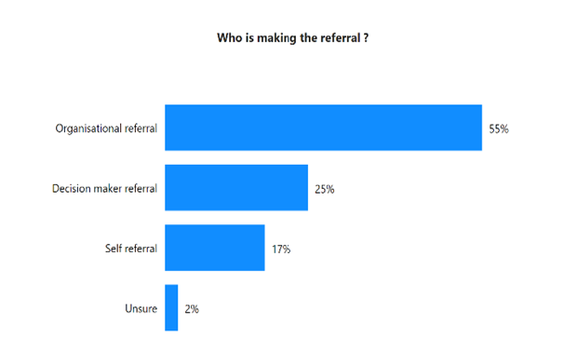
Priority cohorts
Of the total referrals made to ART from TOP, 54.6% were from rural, regional, and remote areas, demonstrating significant need evident in these communities for support and a lack of services delivering support, particularly around access to the NDIS.
QDN created an additional priority cohort category for at risk people for intake and referral, including - people with a psychosocial disability, at risk of homelessness or housing instability, at risk of or experience of domestic and family violence, sexual assault, isolation, and exploitation. This category is reflected as “Other” in the graph. Of all referrals, 20.8% fit within this cohort and indicate a need for ongoing support.
Whilst the project used a targeted engagement approach led by organisations with specific focus/purview for culturally diverse groups (including Aboriginal and Torres Strait Islander people) which resulted in referrals for these groups, the data reflects an intensive ongoing need for culturally appropriate support and services. As indicated in the issues section, these groups need intensive time and relationship building to gain trust and engagement in the access process. In addition to this, this population of potential participants find it incredibly difficult to provide evidence of disability permanence.
While the data for people exiting prison and youth justice is very low (5.2%), this is not indicative of the need in these groups but demonstrates a need for a targeted and integrated approach from across government agencies as well as intensive support from TOP and ART. Additionally, this sector was incredibly difficult to work collaboratively with or obtain documentation from.

Graph 2 - total referrals by priority cohorts
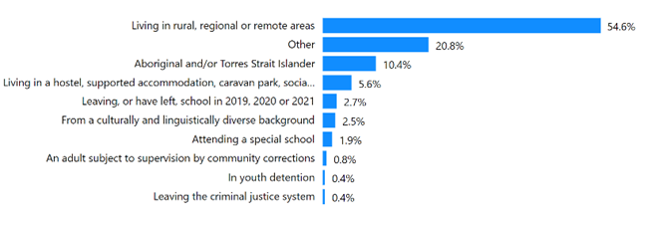
*In the collection of this data, individuals can be categorised in more than one priority cohort, the percentages for each cohort reflect this, rather than an individual.
NDIS applications
Of the people referred to ART from TOP, 22% had previously had their NDIS application denied, generally because they did not meet eligibility criteria of functional impacts or treatment exhaustion. TOP review of their circumstances and in some cases applications, has resulted in these people being referred to ART with additional evidence to support access. There are a range of reasons in relation to why 11% of people are unsure if they have previously submitted an application for access to the NDIS including psychosocial disability, intellectual impairment, prior service intervention, housing insecurity or transience, early hospital discharge or people who have not understood the process required.

Graph 3 – previous NDIS applications
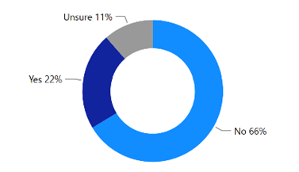

Eligibility requirements for ART referral
Even though most people met eligibility requirements for ART referral, they did not meet requirements for NDIS access. All people referred to ART required additional support to complete their access request form. Without TOP and ART to assist in the process, these people would not have had the right supports to assist their navigation. Coordination, communication, and system navigation are important roles that TOP, and ART played between individuals existing services, to ensure the evidence required was gathered and collated. This is reflective of the need for a more person centred and wrap around support for vulnerable people.

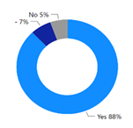
Graph 4 – eligibility requirements for referral to ART
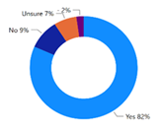

People with a diagnosis People with a regular GP

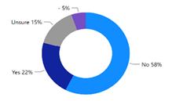
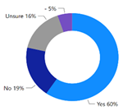

People with regular health professionals (other than a GP) People receiving treatment.

Enquiries – not referred to ART.
Of the 2243 enquiries received and assessed by QDN, 969 (43%), were not progressed to a referral to ART as they were considered ineligible for the NDIS. Of this 969 people, 54% had an impairment not attributable to disability (e.g., a health condition), 44% had not exhausted relevant treatments to demonstrate permanency, 2% of people didn’t experience significant functional impacts.

Graph 5 – enquiries not eligible for NDIS
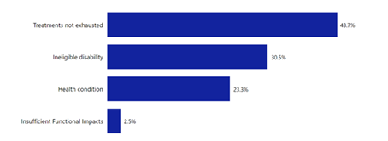
The key characteristics of these 969 enquiries not progressed include:
- 58% were from organisations, 14% from decision makers, and 28% from people with disability.
- 17% of referrals were for people with psychosocial disability.
- 35% were for people in rural, regional, and remote areas.

Graph 6 - enquiries not progressed to referral.
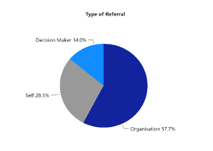
Graph 7 - enquiries not progressed to referral by priority cohort.
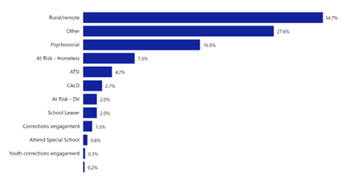

This data indicates that there are high numbers of people with a disability requiring functional support who do not have a permanent disability, and a lack of services to meet their needs. This is particularly true for people with a psychosocial disability from the targeted priority cohorts. People who are financially disadvantaged, or homeless have difficulty demonstrating that they have exhausted treatment options, compounded by the NDIS tightening parameters for evidence for psychosocial disability.

Referral Pathways
The enquiries assessed as not being suitable to progress, required substantial additional work for the intake and assessment team. QDN was committed to ensuring all enquiries were provided with up to date and relevant information for their circumstances and where possible referred to another agency for support. This data provides important detail on the unmet need across Queensland for people with disability who are ineligible for the NDIS. It is worth noting that 26% of these people were not progressed due to inability to contact the person. There are a range of reasons for this, including but not limited to: insecure housing or homelessness, lack of mobile/phone access, poverty, lack of support. This highlights the need for continued targeted support for these cohorts.

Graph 8 – reason not referred to ART.

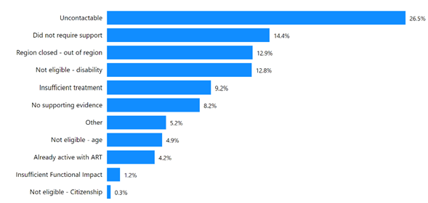

Data indicates that half of all enquires to TOP were people who did not meet eligibility for ART referral pathway. As identified above, reasons for this include but are not limited to; not all treatments have been exhausted, their condition was health related, or their diagnosed disability was not NDIS eligible. Implementation of a ‘no wrong doors’ policy is within QDN value base and as a result TOP time was expanded into ensuring referral pathways were offered where possible.
Through the intake and assessment processes and team reflective practices, it was identified that people need help navigating the systems of support available, whether that be through the NDIS or other funded avenues. There is a lack of current and easy to access information and direction on what is available in terms of support, and how to access it. This was evident not just for people with disability seeking support, but also service providers and health professionals.
Most people not referred to ART were not provided with a referral pathway; however, this is primarily due to an inability to contact people, despite the TOP team following up on enquires on average five times to try and ensure responsiveness to people’s needs. The highest referral pathway provided for people who did not have an identified disability, rather a medical health condition was to other government support systems including Queensland Community Support Scheme (QCSS) (12.9%). People already on a NDIS plan with complications with their plan were referred to advocacy services such as Queensland Advocacy Incorporated (QAI) (2.7%), individual advocacy services (1.2%) or Legal Aid (0.1%). One of the most successful parts of this initiative was being able to give people next steps in their eligibility journey and empowering them to understand the system better.
Individuals were also provided referral pathways and information on how to access treatments required for conditions both medical and disability. Providing a client centric, wrap around service support through provision of transparent information, as well as referral pathways, is a value-based service of QDN and adopted by the TOP team.

Graph 9 – referral pathway provided.
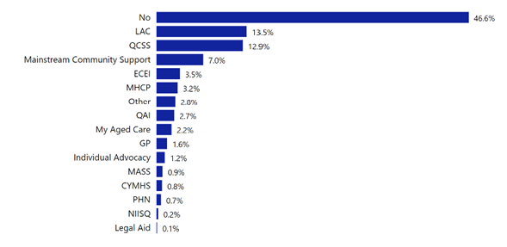

Housing and homelessness
With the assistance of the Supported Accommodation Providers Association (SAPA), the Targeted Outreach Project engaged 24 registered Level 3 Supported Accommodation providers across Phase 4 locations. While some residence managers were difficult to contact amongst their property duties or COVID-19 and flood-related responses, most were able to eventually provide comprehensive feedback about the NDIS status or eligibility of their residents. Many residents of Level 3 Supported Accommodation residences are reported as being diagnosed with psychosocial disability and feedback from their accommodation providers generally surrounded residents as either:
- Being a longer-term resident with a treated and stable psychosocial disability that has already been supported to access the NDIS by mental health workers in the Hospital and Health Service or in organisations funded for NDIS transition support (e.g., Partners in Recovery, Continuity of Support programs).
- Being a longer-term resident diagnosed with psychosocial disability that is untreated or secondary to a more impactful impairment that likely does not meet the disability requirements for NDIS eligibility (e.g., substance use disorder, chronic pain).
- Being a longer-term resident who does not meet the age requirements for NDIS eligibility; or
- Being a more recent arrival to the residence (or only visiting for a short time) and needing support to confirm their NDIS eligibility.
To assist those residents needing support to confirm their NDIS eligibility, the Targeted Outreach Project arranged virtual meetings and visits to 10 x Level 3 Supported Accommodation residences for in-person conversations about accessing the NDIS. Across Phase 4 locations, TOP progressed 7 residents of Level 3 Supported Accommodation properties to ART for NDIS access support. The main identified issue was for longer term residents with untreated psychosocial disability or with an impairment that likely does not meet the disability requirements for NDIS eligibility (e.g., substance use disorder, chronic pain). People in this type of accommodation are extremely vulnerable and are not receiving adequate support, particularly those requiring continued treatment options or that are not eligible for NDIS access.

Regional ART data
As of 31st March 2022, when referrals closed, the TOP referred 1,284 people to ART, with 630 of those referrals resulting in access approval by the NDIA. Maroochydore region resulted in 86 of referrals getting access to the NDIS, with Caboolture/Strathpine having 81 people being approved for the NDIS. Of those referrals 67 applications are still in process awaiting documentation and/or assessments and 49 of applications with the NDIA awaiting approval. The regions with the least amount of people with approved access to the NDIS were Cairns (5), Robina (15) and Maryborough (19). Additional detail on ART referrals by region can be found in table 2 below.
Table 2 – ART referrals by location
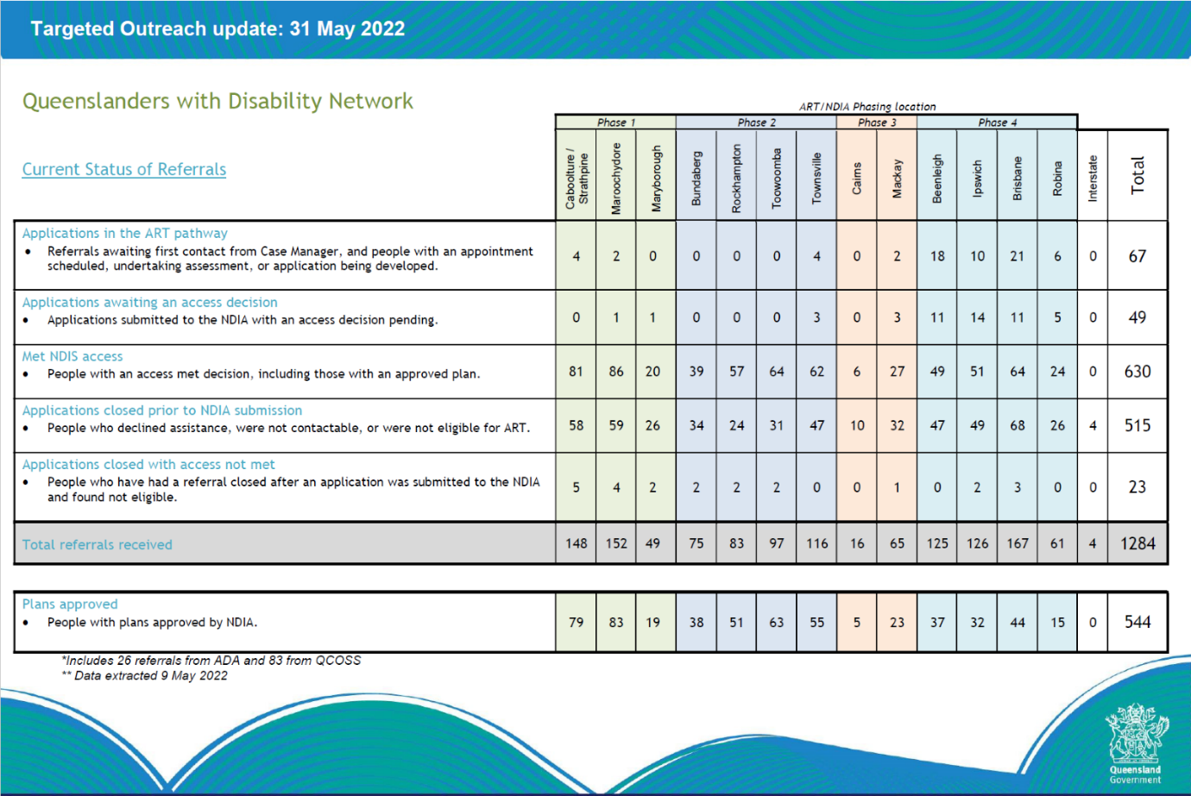
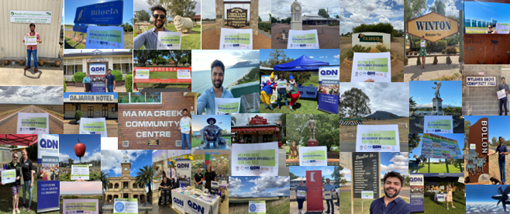
Engagement/capacity building
The TOP model invested time and resources into place-based Local Level Engagement Groups, Local Champions, and the development of Local Level Engagement plans, built on existing community knowledge of each unique region. Utilising the strengths within each individual community to understand what engagement strategy would reach the highest success outcomes contributed to TOP success.
Across all locations, the TOP delivered NDIS general information, NDIS access and referral information, referral pathways information on 2731 occasions.
This was delivered through network meetings, staff training days and community events as well as via phone and email correspondence directly to 5160 organisations through a variety of settings to 10,183 community leaders and human services workers.
Understanding demographic information of a region is vital for TOP engagement to develop a clear understanding of the strengths and limitations within each community. Beginning with an asset/eco mapping approach, TOP staff simultaneously complete desktop research whilst also engaging with on the ground local community service organisations. This process includes exploring ABS statistics, media articles and service mapping in addition with QDN’s own membership base, identifying what services or members already live within the community that can provide valuable community knowledge.
Connections within community of either existing QDN or partner organization (QCOSS, ADA, AMPARO and QDN members) and their members or networks allows TOP staff to gather a greater understanding of local trends, upcoming events local to that region, and what is accessible within the community. The process of community profiling provides valuable information and assists to identify ‘on the ground’ community stakeholders. Community stakeholders are the experts on the ground who can inform and identify what is happening in the community and what gaps that are existing that may create additional barriers to accessing a community and promoting TOP, ART, and NDIS access. Being aware of these allows TOP staff to identify how to break down these barriers to ensure that when they visit community, they achieve the successful intended outcomes of the project.
The successful outcome of this engagement is reflected in direct referrals to TOP, ART and in evaluative feedback provided by service providers. The evaluation survey demonstrated 83% of service providers were satisfied with the engagement, support, and delivery of the TOP approach.
The TOP model was originally strongly founded on ‘in community’ engagement and face to face work with organisations and service users. This was impacted by the Government health directives that came into place in response to the COVID-19 pandemic in 2020. At the time of project launch a revised three-month plan for NDIS Targeted Outreach was created that aligned with the Department’s ART and COVID-19 emergency response efforts.
QDN and the consortia had to ‘pivot’ quickly and work with key local service providers and new and innovative ways to engage ‘harder to reach’ participants. During the peak of the pandemic, the Department restricted all engagement with Aboriginal and Torres Strait Islander communities. This shift in mode of delivery, slowed the number of referrals in the first regions to be rolled out.
The table below demonstrates the breakdown of engagement per region and the numbers of organisations and people engaged in each region.

Graph 10: regional engagement
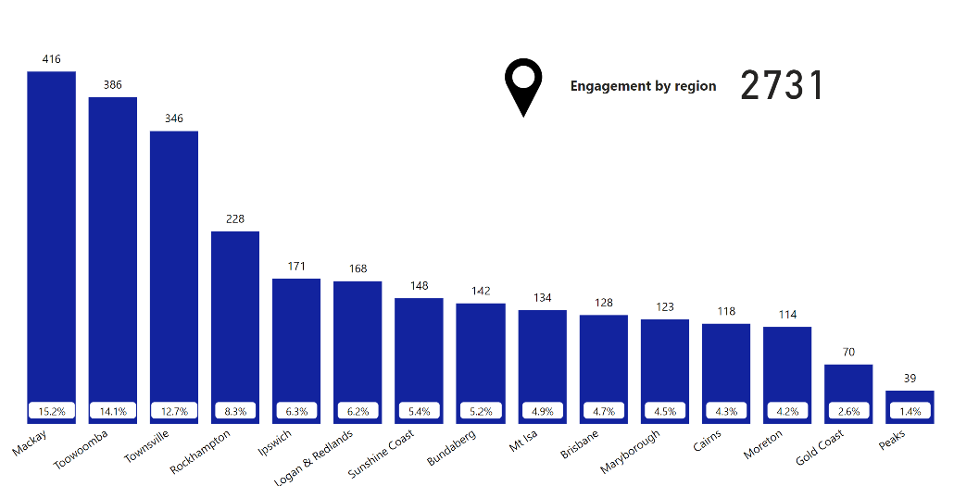

Graph 11– Organisation engagement by region
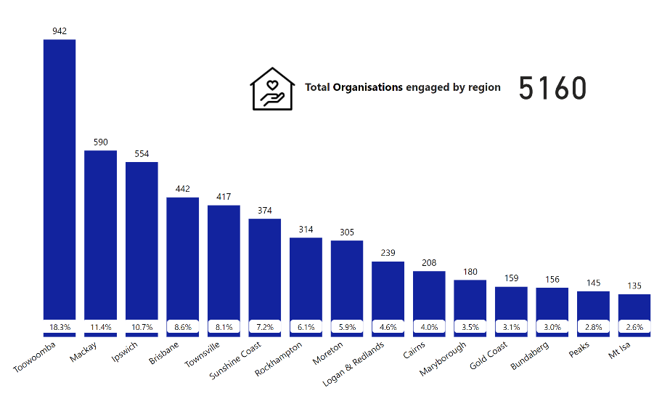

Graph 12 – (Staff) engaged per region.
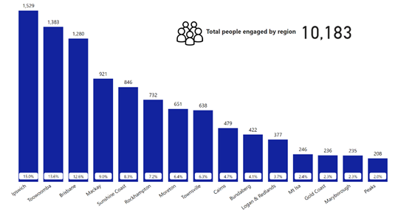
Direct face to face engagement was delivered in a variety of community-based settings. The type of activity was reflective of the Local Level Engagement Groups (LLEG’s), tailoring to the need of each individual community. Engagement activities stem from initial email and phone engagement through to in person one on one information, organisational staff training, network participation and information sharing, and participation in public community events. Introductory calls and emails showed to be the highest engagement as this was the first stage of identifying best practice within each community. In person meetings followed by Community sessions were the most frequent face to face engagement. Due to COVID, many initial community engagements were delivered via virtual means.
To generate referral results, the outreach project delivered engagement activities in 19 separate settings ranging from a relatively formal setting of school/education facility through to that of a caravan park. The settings that generated the most engagement and referrals throughout the TOP were in Disability Services (14.6%), Health services (13%) and Neighbourhood Centres (10.7%).
As can be seen in Image 4 below, the lowest number were engaged through the community legal centre and accommodation setting.

Graph 13 – Engagement Activity

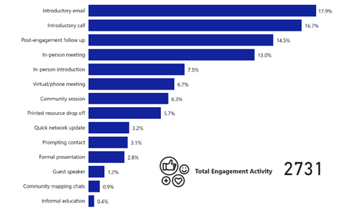

Graph 14 – Setting delivery of engagement activity.

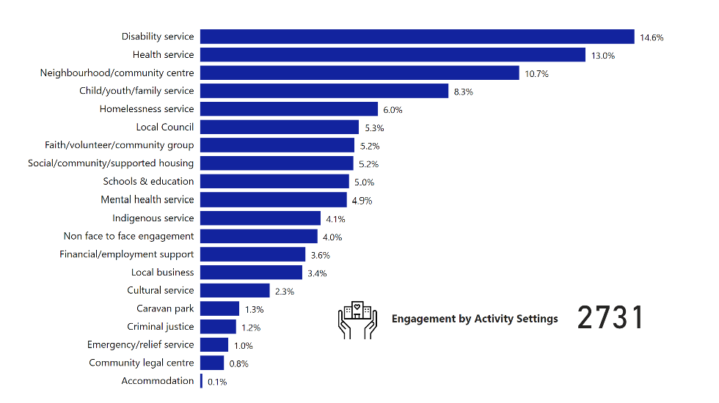

Due to significant challenges within rural, and remote communities, and lack of access to support services, it was essential to develop a dedicated and targeted engagement approach in these regions. This is reflected in quantitative data where by 44.8% of engagement was focused here. Geographic location promotes a greater risk of social and systemic isolation leading to more time required to spent within these areas to ensure information, education, support, and referral pathways were accurate and met the needs of these communities. Often these communities required additional time to build trust and relationships to ensure the TOP was meeting need. Reflected in the graph below is a clear visual representation of engagement over the span of the priority cohorts.

Graph 15- people engaged by primary cohort.
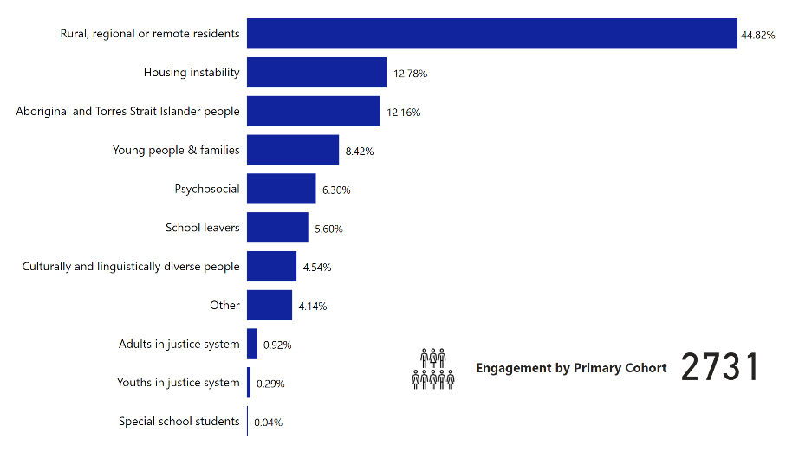

Local Champions
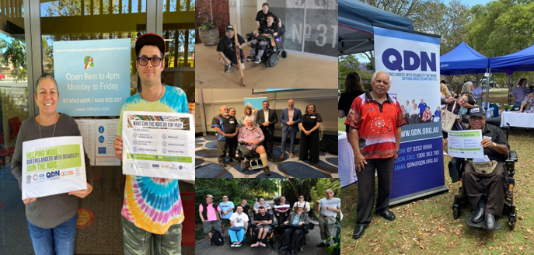

The 21 Local Champions (LC) recruited for the outreach project have proved central to the success of the outreach project, bringing personal experience of living with a disability and the NDIS journey. This combined with their local knowledge and understanding of their communities, contributed to the development of local engagement activities and plans.
Local Champions delivered a range of work for the project and were engaged and remunerated for their time and expertise. The evaluation demonstrated that the structures of meetings, workshops and supports that were established for the 21 Local Champions enabled them to support each other, with more experienced peers providing important informal mentoring and support throughout the project to the newer leaders (Community of Practice).
Regarded as a trustworthy connection for many potential applicants, the champions are natural ambassadors for the NDIS. Their lived experience meant, for example, that they replaced NDIS jargon with uncomplicated explanations, offered encouragement and took the time to build trust with potential NDIS applicants. The fact that the community is their community builds visibility and recognition as the ‘go to’ approachable NDIS person.
Local Champion involvement in TOP was individually designed based on the capacity and choice of the individual. This included the individual’s capacity and level of commitment they were willing and able to contribute. This support included but not limited to; participation in community engagement, promotion of TOP, connections to key community leaders, direct one on one engagement and support for potential NDIS participants and direct referrals into TOP.
Recruitment and development
Local Champions were recruited in each location from existing QDN networks. Local Champions bring a perspective of living with a disability and in the words one Local Champion ‘you can’t do any better than that – local people have local knowledge and have connections that others simply don’t have’ (direct feedback from LC roundtable discussion).
In effect, they offer ‘street cred’ through sharing their own experiences as NDIS participants. Local Champions are using their lived experience within their communities to share their stories of any barriers to access they have faced, and strengths within their communities when engaging in everyday activities. The Local Champions were supported by project team members and attended minimum monthly team meetings to provide feedback and gain understanding of alternative strategies being used by other Local Champions in their areas.
They were phased in their recruitment as each stage of the project rolled into scope. One experienced Local Champion, well known in his community, suggested that all Local Champions could have been recruited at the same time, to start the early information provision process, to ‘seed the ground’ for later more involving engagement and information events.
Motivation behind a Local Champion 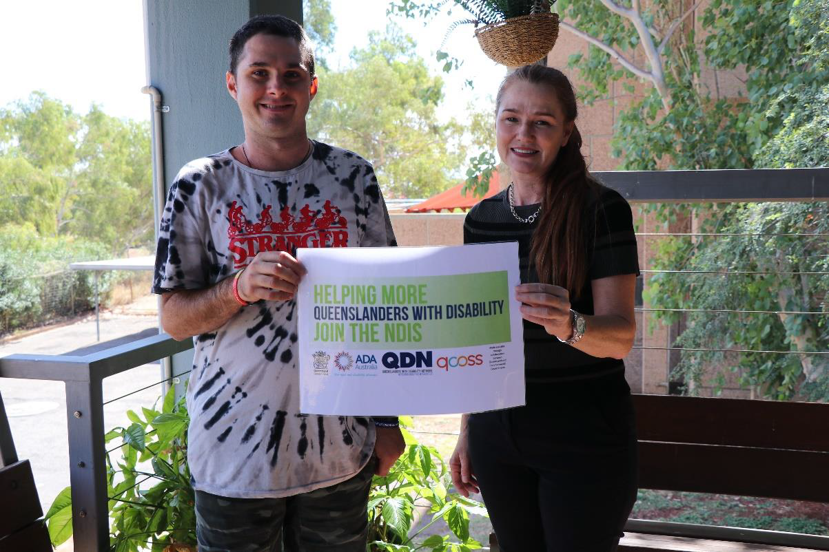
Mt Isa – Local Champion Jordan Dank

The majority (78%) of Local Champions identified commitment to the community as the reason they were able to fulfil their role in the project with 67% noting support from QDN played a part. Training and time to commit to the role rated equally at 44% with champion’s personal care and support team and payment featuring to a lesser extent.
A combination of factors made the difference in fulfilling the Local Champion role with one respondent noting, it was ‘a wonderful experience’, another ‘learning new skills …’ and in reference to payment, ‘would have participated as a volunteer, but being paid means … project higher priority … important to be professional in a paid role’.
The part of the role most important to Local Champions was NDIS awareness raising (88%), with one commenting, ‘I thought it was absolutely fantastic that QDN engaged people who experience disability to do this role… It was such an opportunity … to be engaged… and be rewarded financially for time and effort. To … [be] shown, by more than words that they were valuable. Financial renumeration is a mark of respect for capable able individuals.’
Not unsurprisingly, given the ‘volunteer’ spirit, the two most enjoyable aspects of the outreach project were that of raising awareness of NDIS and connecting with community groups, both at 88%, with over half of respondents (55%) identifying both the team approach to community outreach and that of providing valuable community knowledge – ‘being able to provide valuable contacts for people curious about the NDIS’, ‘the help I was able to supply to people with a disability to navigate the system’ and ‘ it was about talking about the positives of the NDIS … because that is a permanent support that goes way beyond the length of the project’.

Graph 16 – what made it possible for you to fulfil your local champion role in the project?

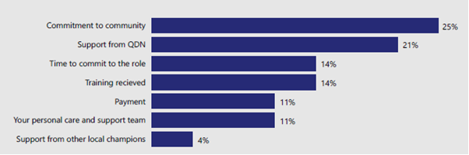

Local Champion Stated Challenges
Only 66% of Local Champions responded to the survey question regarding the hardest part of the role. For those that did, engagement with the community, engagement with the individual and the referral pathway to TOP intake were most selected survey choices. Additional observations, noted the need to have feedback on application numbers deemed ineligible and the reasons, and the need for more training given they are/were the ‘face of’ the targeted outreach project.
A small proportion of Local Champions suggested that sometimes it was disheartening to hear that people they had engaged with didn’t meet ART criteria, couldn’t afford, or geographically access services to get the evidence they needed, or chose not to progress. At times the scope and volume of ‘known local’ demand was suggested to be a bit overwhelming.
Local Champions reported that the role at times was quite stressful and a tiring experience. Many Local Champions also have other roles, work, or their own personal commitments. In the evaluation there were several examples where participants responding negatively (due to trust and previous traumatic concerns) to the Local Champion. Some of the less experienced Local Champions may not have had the skills to deal with a hostile participant, when they are there only to assist. The QDN project team and more experienced Local Champions provided support if these situations arose. The need to debrief and download is an important part of Local Champion support infrastructure.
Face of the community
The funding contract asked QDN and the consortia to identify an appropriate Local Champion from each location who has local knowledge and established relationships and can act as the ‘face’ and representative of outreach activities; and can actively encourage potential participants to engage with the targeted outreach project (See Appendix B).
This was achieved with several Local Champions already being known in their local communities given their position and history in disability advocacy in some cases for many years. Being a ‘face’ for the project is something, the evaluator notes, cannot be unseen once the project has come to an end.

Graph 17 What did you enjoy the most about your local champion role?
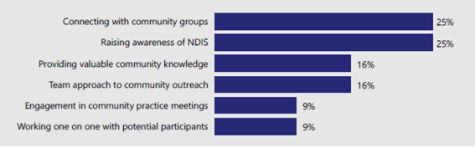

It was noted that after each phase, exit sessions are held within the community to inform services and individuals of the Targeted Outreach Project and ART’s exit processes and offer alternate options to seek support and assistance. Feedback from Local Champions during interview identified they would be happy to continue in the role, others suggested they had been doing the role ‘unofficially’ prior to the project commencing. One local champion said that he is still having people with a disability come up to him in the local community and ask for further information or to provide an update on their NDIS planning process.
It is recommended that the concept of Local Champions be supported to continue. The ability for nominated Local Champions to be compensated and/or at a minimum be recognised for their important local engagement work and provided leadership and collaboration opportunities with other Local Champions accordingly. It is important more generally that these very talented local people with disability are not ever taken for granted to provide this service as an alternative to appropriately funded projects.

Graph 18 – What is the most important part of your role as a local champion?

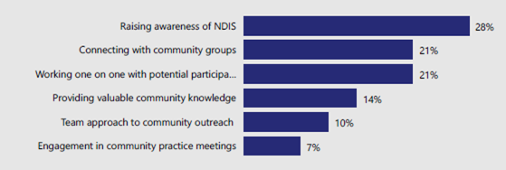

Ideally, given the recognition of need for TOP to continue, the number of Local Champions could be progressively expanded so that rather than just regional representation, they are also in towns/smaller community settings. This would also ensure that there was not ‘fatigue’ in the Local Champion network and that a peer support model operates for those champions newer to the role; together with appropriate remuneration and specific training which encompasses the key stages of the NDIS system including post plan creation support information.
QDN would like to acknowledge the commitment and passion of the first Local Champion Matt McCracken. Matt was an integral part of paving the way for all Local Champions to follow and provided many opportunities for engagement and support in the Moreton Bay Region. Matt provided strength in advocacy and influenced systemic change within his local community. It is sad to note that Matt passed away before the conclusion of the Targeted Outreach Project however his legacy will live on.

Survey outcomes
Surveys were distributed to members of project consortia, services providers, and individual participants. Below is a breakdown of the responses to the evaluative survey.
Project Team and Consortia
Consortia members are made up of QDN staff and management team, project partners QCOSS, ADA and AMPARO Advocacy, stakeholder groups as well as a dedicated project advisory team. To oversee and maintain high outcomes standards and cohesive work practices, the project advisory team (representing all services involved in TOP delivery) convened monthly. Feedback was sought from the consortia in the form of a distributed evaluative survey only, with four project team members, two consortia partners and a subcontractor engaged in the later part of the TOP completed the survey (7 responses in total).
All survey respondents believed the project successfully met its objectives with an overall average rating of 4.4 from a possible 5 stars. Consortia partners each gave the project a 5-star rating.
In response to how easy was it to be involved in the project, an average rating of 4.2 stars was accorded, this being attributed to effective communication and teamwork, regular meetings and a well-planned, considered approach to implementation. The project team were regarded as responsive to queries and feedback. While involvement was regarded as relatively easy, some project challenges were apparent. These centred on moving the project from concept to implementation - rolling out a place-based model when the project team are centrally located and seeking to engage with target groups, some with complex background circumstances not known for engagement with existing service systems. Although the project has been successful, ‘the need for flexibility and more time may have enhanced outcomes further’.
Themes regarding the most successful aspect of the project other than actual referrals were:
- The TOP model itself as a demonstration of delivering person centred care, building capability at local level through a program/service that meets client needs where they live.
- The importance of Local Champions bringing their lived experience of both disability and NDIS journey, in effect giving potential NDIS applicants a ‘constant’ in their local community.
- Raising knowledge and awareness of NDIS in rural, regional, and remote locations, particularly where Local Area Coordinators do not visit and identifying and locating many who would otherwise be overlooked.
- The outreach, despite COVID19, and the opportunity provided to develop working relationships with many community organisations.
In response to what could be done to improve results (referrals and/or outcomes for people with a disability), respondents provided a rich tapestry of ideas themed not unexpectedly on resources – funding, staffing, and time. The suggestions included:
- Having more local champions based in local towns and communities could enhance local based relationships and connections.
- Examine how to build capacity of local champions and services to support people’s action in gathering evidence.
- An extended and more realistic time frame in regions (Brisbane in particular) to build stronger relationships with community members and potentially increase referral rates as a consequence (in many regions for the majority of project, the beginnings of trust were just occurring when each project phase ended).
- Funding increase generally and a case manager function to assist with those especially vulnerable applicants.
Consortia’s reply on focus areas to improve application uptake from people with a disability rated highest for ‘making NDIS a topic for health professionals, a part of ‘grand rounds’ at 71% and ‘within service providers organisations’ (43%). While ‘in house training’ at 29% rated equally with, ‘information provision’ and ‘Local Champions’.
In the words of several respondents:
‘The general understanding of NDIS access across the field of health is not good, and further work needs to be done across this sector to enable people with disability to be empowered to understand their own health needs/records etc.’ (Respondent 3)
‘There is still so much misunderstanding around the NDIS application process and complexity for both service providers and applicants. providing simple more targeted support would assist with uptake. building the capacity of Local Champions and resourcing them to link people into TOP in an ongoing way would also be beneficial’. (Respondent 4)
‘Stronger partnerships with local organisations - spending more time in community to build those relationships so that we could even more effectively leverage off existing relationships in community, and hold community sessions to improve uptake etc. Through our engagement we built relationships with local organisations, however, time constraints and not being able to spend significant amounts of time in each community meant that relationships weren't as strong as they could have been’. (Respondent 5)
There is clearly a need for NDIS awareness and understanding across the board – people with a disability, service providers, public and private health sector etc. A way this might be done would be through a revised and expanded role for Local Champions. This would need to be funded, training would need to be provided, Local Champions numbers would need to be increased and the interface (role clarification) with QDN staff and the Department’s assessment and referral team (assuming a continuation) would need to be explored.

Graph 19 – areas to improve.

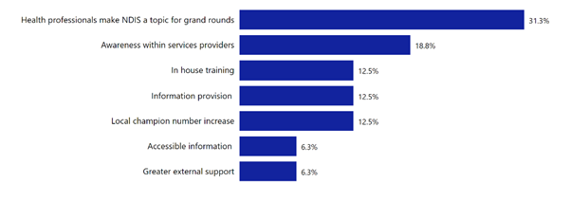

Participants
Participants were directly engaged in a feedback process through the distribution of an evaluative survey. Distribution was based on participants referred into TOP, including those referred to ART and those on other referral pathways. Distribution of the evaluation was through emails and text and was reliant of TOP having access to these contact details.
Survey responses were received from 38 participants. Of these 21 (55%) had previously applied with 13 expressing satisfaction with the engagement outcome.
‘My first time applying for the NDIS on my own was a drawn-out (for months) traumatic affair … left me … afraid of the process. I'm so grateful to the friend who heard about the Targeted Outreach Program and told me about it; I've no doubt it was their assistance that got me across the line the second time I applied’ (participant 1)
‘I will be forever grateful for the help I got through the project, that ultimately helped me get funding’ (participant 2)
‘[I] had one failed attempt at doing NDIS application … myself, was unable to do another application without their help’ (participant 3)

Graph 20 – evaluation outcome participants

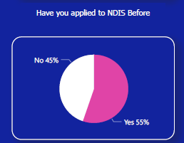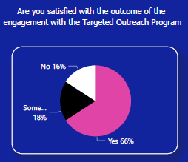

Six applicants reporting being somewhat satisfied with their support and attributed this to a range of issues including the stressful and complex nature of application, needing more help stating NDIS ‘wouldn’t help’. Another survey respondent reported that it was only after experiencing a crisis during the application process and subsequently becoming aware of QDN was their application quickly approved. This applicant adding ‘I am unsure if QDN had any input in this, but I do believe it is a much needed and valuable service that simply needs more exposure’.
For the two unsatisfied respondents, one offered additional comment noting the combination of their multiple impairments and contributing health effects were not taken ‘… seriously enough …’ in helping to describe ‘the functional impact of [all] impairments’ on their ability to participate in life as a person with a disability.
When responding to the aspects of the outreach project that worked well, most participants selected multiple factors. However, ‘quality of information’ was identified by 21 respondents, 20 selected ‘knowledge of the team’ and 19 noting it was ‘easy to engage’.
‘The team were very knowledgeable and allocated the time I needed to focus on the information required through in-depth interviews. It took a lot of time and sometimes it felt very brutal trying to excise one chronic illness while evidencing another - from my point of view living with multiple related conditions, separating one from the other is pointless as they aren’t separate but reactive and work together to create an insurmountable challenge to daily living’.
The key factor identified by survey participants in responding to what aspects of the overall ART program worked well, was that of ‘Support to access NDIS’ (68%). However, as respondents could select multiple items, ‘Assistance to access information to apply for NDIS’ was rated highly at 60% along with ‘smooth referral pathway’ (52%).
‘My experiences with the ART program were all extremely positive. I was grieving for my mother who had recently died. I was overwhelmed by my diagnoses, two heart surgeries, radioisotope therapy and ongoing chemotherapy. I was at my lowest point.’

‘The ART program lifted a burden from me. The people who worked with me were all I could wish for.’
‘The process was a bit confusing, but they informed me very well every step of the way.’
Overall, the perceptions /experiences of participants can be captured by this comment from a client with a primary diagnosis of psychosocial disability ‘Only, "Thank you, thank you, THANK YOU!" I was sorry to hear the program had been closed down as it would have helped so many people overcome the challenges encountered in accessing the NDIS.’
A range of factors critical to ensuring vulnerable and hard to reach people with a disability continue to apply for NDIS. These include:
- Ongoing access to experienced Local Champions – being in the community and representing a departure from government services.
- Ongoing support to navigate the NDIS stages -case management from access to planning to review.
- Outreach services delivered locally where engagement occurs in a safe and secure environment for the person with a disability,
- support to understand what documentation is needed.
- greater understanding by medical practitioners about their role in assisting with the necessary NDIS documentation and ongoing support for free/Medicare covered assessments.

Graph 21 – Participant survey feedback
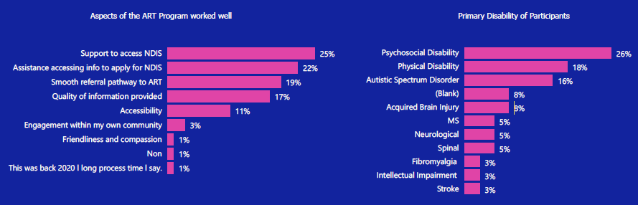

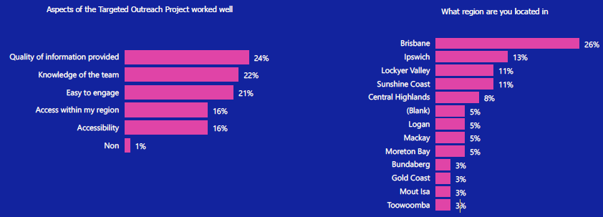

Referring organisations (service providers)
Referring organisations participating in the evaluation survey were from state and local governments, non-government organisations and the private sector, their core services being mental health, psychology, disability services, neighbourhood/community centres, child/youth/family services and schools/education.
A two-stage process of engagement was developed as they were intended to be the primary referral source of people from the targeted cohorts. Working with Local Champions and through the LLEGs, tailored local engagement activities were conducted to raise awareness of the outreach project and in doing so, identify from their client bases, people with disability, potentially eligible for referral to ART meet access NDIS requirements.
A total of 36 service providers responded to the survey. The survey provided for multiple selections for many of the questions. The responses came from service providers across the geographic area of the TOP project including urban, regional, and remote locations such as Brisbane, Logan, Ipswich, the Gold and Sunshine coasts, Bundaberg, Townsville, Cairns, Mt Isa, and Longreach. Fifty percent of survey respondents were from Not-for-Profit organisations. Most responses came from organisations in Brisbane, Ipswich, and Logan (Beenleigh) at 44%.
Service providers identified their roles in terms of engagement with TOP as indicated in the image below, primarily as a referral agency.

Diagram 1 – service provider roles
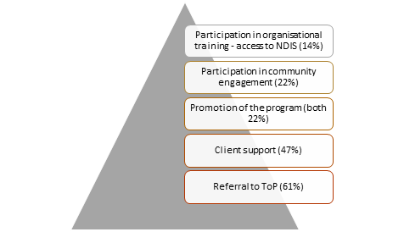

Seven providers did not see their organisation’s role as that of assisting people with a disability to access the NDIS. One service provider (educational facility) noting while it was not their role they acknowledged if they did not help, the person with a disability would not be able to access NDIS. Another respondent (NFP) saw their role as partial assistance only with referral to the NDIS partner/s in the community.
‘LACs were originally funded to undertake the role of supporting people to access appropriate disability supports, however, they do not provide people living with a disability the hands-on assistance that they need, especially when they have other barriers to access. As there is nowhere to turn, they turn to advocacy, but the LACs should be funded to provide the level of assistance needed or ART/TOP should be funded to continue.’ Community based organisation.
‘Although our org[anisation] do[es] not predominately assist with access I have assisted on numerous occasions due to no other agencies being able to assist’ Community based organisation (remote location).
Service providers report being more confident (58%), or somewhat more confident (28%), in their NDIS access capability/knowledge to support people with a disability understand eligibility and access requirements.

Graph 22 – survey outcomes service providers

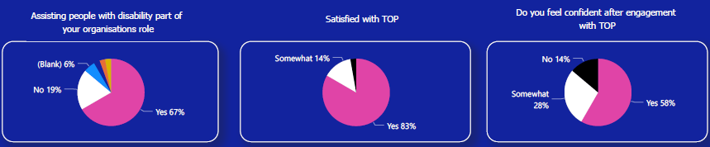

Organisational capability/knowledge improvement
Half (50%) the service provider respondents stated their organisation’s capacity to assist with a NDIS referral changed or somewhat changed (28%) because of the TOP. One service provider commenting:
‘While a goal of our organisation is to assist … as a small business …[we] limited capacity for the] pro-bono work … required to assist … with the access process. Some of the larger providers are able to provide targeted support but there is a major service gap for access support to the NIDS for eligible participants without capacity to navigate the access process independently. (Service Provider)
It was noted through the survey and interviews with Local Champions that some areas had high turnover of NDIS staff. This meant that internal organisational capability that may have been raised then was lost with staff movement. One comment provided context of the impact of this capability change on people aiming to access the NDIS.
‘The sad part is the person has a first plan and is getting used to a worker and then go back to finish things and you have to start all over again and get to know someone else’.
Movement in the workforce (which is occurring reasonably often in this challenging sector) adds further complexity to the trust development process.
Future referrals
A large majority (92%) of service providers offered many and varied responses to what needed to be in place to encourage future referrals. This ranged from continuation of the TOP or similar program, training on the full application process, support /case management for the client (especially those with complex needs) and better access to the documentation needed to prove NDIS eligibility as this can be time consuming and costly.
There is an ongoing need to provide a dedicated service to provide the more intensive support for participants who are seeking to access the NDIS process. Many service providers not having the detailed knowledge of the NDIS eligibility criteria, how to prove permanency, and how to evidence the day-to-day functional impact of a person’s disability.

Satisfaction with the TOP
97% of service providers were satisfied overall with the support from the TOP, with ‘quality of information received’ the highest at 75%. The importance of an understanding of NDIS from a person with lived experience was favoured (47%), as too, the satisfaction with clear referral pathways (61%). Additional comments included:
- having professionals able to provide evidence for access.
- having a young person successfully connected to NDIS.
- being available in regions, and
- a general helpfulness, advice, and consideration of vulnerable families.

Program approach and impact
The results, feedback from Local Champions, LLEGs, focus group/s and survey instruments clearly point to the continuing need for the approach, model, and services/support that this project delivered to people with disability who are considered ‘hard to reach.’ The model is premised on taking the services ‘to’ the target cohorts, delivery by a state-wide organisation – not a government agency and, vitally one delivered with people with disability with lived experience of NDIS access.
Importantly, an approach to NDIS access that recognises community members participation in the Scheme relies on trust and building trust with potential participants takes time. The lived experience, provided locally by either community-based organisations and Local Champions will deliver the best possible outcomes for people with disability and their families, and by the respective levels of government.
Trust building is an area that cannot be rushed or made ‘more efficient’. Local Champion reflections suggest that for the harder to reach cohorts need a more personalised approach in a place they go to. One Local Champion stated, ‘you can no longer put out a flyer and expect a person to show up. Unless you get someone to tell a personal story or give a personal reason or the benefit to me being involved, they won’t show up’.

Final evaluation conclusions
This evaluation can only be considered with the in-depth quarterly reports provided by the project throughout its delivery. These reports have many individual stories of impact and summaries of the opportunities and successes. The data is unambiguous and supports that the targeted outreach project has been a success, supporting and changing the lives of many people with a disability throughout Queensland. However there remains a large challenge ahead and the evaluation has demonstrated that continued funding of models such as the Targeted Outreach Project are needed in response to the complexity experienced by many people with disability requiring support. If equity of NDIS access is one objective, then the work of this project needs to continue progressing in those locations and with people with a disability in complex circumstances to get access.
One case in particular in a report in November 2021, highlighted the case of a man with a primary disability of a Traumatic Brain Injury and further mental health challenges. He had no support in his local community, no family and had not been connected to any services. He heard about the Targeted Outreach Project through a community member who attends emergency relief events to access meals. Local Champions and project members attended the Emergency Relief event and had a conversation casually and then stepped through a process to build trust carefully. The Local Champion shared their own personal story of how they accessed NDIS planning processes and this reflection built further trust and readiness. Due to the personalised approach, this man, who was outside of ‘the system’ of support and had been cautious and sceptical, took the step and was referred to the ART pathway and is on the way to having a plan and more hope in his future.
There are many other stories such as this man. It is those stories that showcase how valuable a peer lead process such as the Targeted Outreach Model can bring positive change. Local Champions have been seen by many to be the key to this success and their ‘big hearts’ need to be recognised and future models of support maintain compensation for this vital service offer. Ideally these Local Champions can be involved in all aspects of NDIS programs and policy. The evaluation would suggest that if funding was to be continued, that compensated Local Champion numbers could be expanded with the explicit supports of training, remuneration and mentoring.
There is a need for continued coordination and information sharing between the levels of government, service providers and people with a disability. This model was refined as it was rolled out, customised for place and participant. The model needs to be described for future us. Iterative learning has improved TOPs approach as the project progressively rolled out highlighted broader systemic issues impacting people with disability in local communities. The learnings are gleaned through conversations and other community engagement, which informed understanding project team members and Local Champions alike. This information on the local community and systemic challenges and opportunities could be very valuable as NDIS continues to evolve and expand in its coverage.

NDIS (2023, December 31). NDIS Quarterly report to disability ministers. PB Report to disability ministers for Q2 of Y10_Full_Report (1).pdf
Australian Institute of Health and Welfare (2022) People with disability in Australia, AIHW, Australian Government, accessed 05 May 2023.

