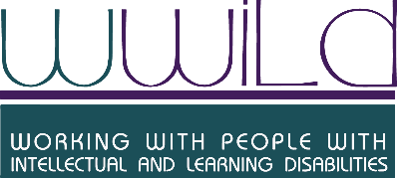

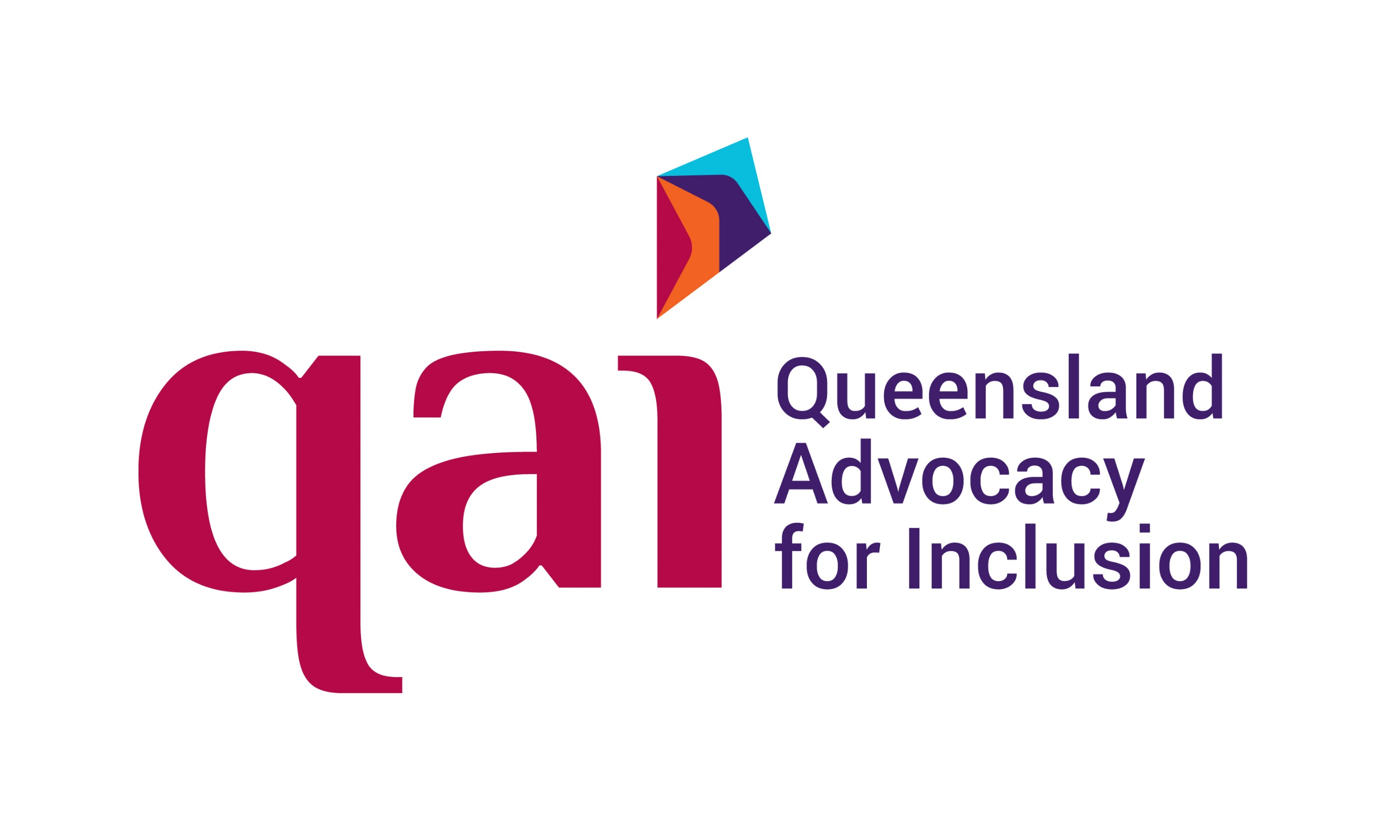

Joint Submission

Removing legislative inconsistency in the Criminal Code regarding consensual sexual expression for people with intellectual disability

To the Housing, Big Build and Manufacturing Committee on the Criminal Code (Decriminalising Sex Work) and Other Legislation Amendment Bill 2024

March 2024

About QAI, QDN and WWILD
QAI, QDN and WWILD are key organisations in the disability sector in Queensland.
- QAI is an independent non-profit that provides advocacy, legal advice, and systems advocacy for people with disability in Queensland.
- QDN is a state-wide non-profit focused on disability rights and advocacy, led by people with lived experience of diverse disability.
- WWILD provides counselling, social work support, therapeutic groups to people with intellectual disabilities age 12 and over, who are at risk or have experienced sexual violence, crime or exploitation, and provides community education and training.

Submission contacts
Matilda Alexander, Chief Executive Officer
Queensland Advocacy for Inclusion
qai@qai.org.au
(07) 3844 4200

Michelle Moss, Chief Executive Officer
Queenslanders with Disability Network
qdn@qdn.org.au
(07) 3252 8566

[insert name], [insert title]
Working With people with Intellectual and Learning Disabilities
info@wwild.org.au
(07) 3262 9877

Executive Summary
Legislative inconsistency significantly impacts people with an intellectual disability
Under section 216 of the Criminal Code 1899 (Qld) (the Criminal Code), it is currently an offence to engage in sexual activity with a person who has an 'impairment of the mind'. The definition of 'impairment of the mind' includes anyone with an intellectual, psychiatric, cognitive, or neurological impairment that causes a substantial reduction of the person’s capacity for communication, social interaction or learning, and the person needs support.

There is currently legislative inconsistency between s216 of the Criminal Code and the following legislation:
- Anti-Discrimination Act 1991 (Qld)
- Guardianship and Administration Act 2000 (Qld)
- Disability Services Act 2006 (Qld)
- Human Rights Act 2019 (Qld).
The Queensland Public Advocate highlighted these inconsistencies in its January 2022 report on s216.

As part of decriminalising sex work in Queensland, the Criminal Code Decriminalising Sex Work and Other Legislation Amendment Bill 2024 (the Bill) will remove references to 'impairment of the mind' in s229L of the Criminal Code. QAI, QDN and WWILD support this amendment to s229L. However, without repealing s216 of the Criminal Code, there will be a significant inconsistency that remains in force in legislation in Queensland. This inconsistency would disadvantage and discriminate against many people with disability, and in particular, people with an intellectual disability.

Consequences of s216 offence for people with an intellectual disability
- Breadth of definition – wide-ranging impact
The broad definition of 'impairment of the mind' has the potential to include many people with a disability who, despite their disability, still have the capacity to decide to engage in a consensual sexual relationship. The Queensland Court of Appeal has expressed concern that the definition is so far reaching that it simply requires some level of neurological impairment that affects the power to communicate. For example, the definition is so wide as to "include a cerebral palsy sufferer of 'genius IQ'".

While the purpose of section 216 of the Criminal Code may be to protect the vulnerable from sexual exploitation, the consequence of the provision is to render many naturally formed and informed sexual relationships illegal. Essentially, this prohibits intimate relationships for many Queenslanders with a disability, including all Queenslanders with an intellectual disability. This has the potential to have a wide range of detrimental effects; they may experience social isolation, loneliness, rejection, all of which impacts the person, their family, support systems, and ultimately, the health system.

- Inconsistent with accepted position on decision-making capacity
The definition of 'impairment of the mind' which is key to s216 does not reflect the widely accepted position that decision-making capacity, including for sexual activity and expression, is contextual. Capacity is decision, time and situation (or 'domain') specific. All adults at law are presumed to have decision-making capacity until proven otherwise, and capacity must be assessed every time a person makes a decision. This is the position in other Queensland legal contexts, such as the Queensland Capacity Assessment Guidelines 2020 and the Guardianship and Administration Act 2000 (Qld). The courts have also supported the position that a person with intellectual impairment can have the capacity to consent. Refer to Appendix 2 for summary of a case law example which demonstrates how the courts have interpreted this provision.

- Human rights and discrimination impact
People with intellectual and or cognitive impairment have the same human rights to engage in relationships as anyone without a disability. Section 216 of the Criminal Code, as it stands, impedes those rights and in doing so, is discriminatory, in the sense that they are treated less favourably than others by the law. This provision is also contrary to Australia's obligations under the Convention of the Rights of Persons with Disabilities (CRPD), particularly articles 5 and 23.

- Difficulty of exercising available defence under s216
Although section 216 provides a specific defence if the conduct did not constitute ‘sexual exploitation’ the provision still has the effect of criminalising all sexual contact with a ‘person with an impairment of the mind’ unless proven otherwise. This creates a situation where, even if the sexual activity involved people who were capable of giving consent, the onus would be on the alleged perpetrator to prove that their relationship was not one of sexual exploitation and that they believed, on objectively reasonable grounds, that the other person was not impaired. This involves invasive scrutiny of the "victim" and their impairments to assess whether the conduct was sexual exploitation.

The position in other States and Territories
The Public Advocate highlighted that: "Section 216 appears to be the most restrictive of this type of offence provision among Australian states and territories." All other jurisdictions adopt a consent-based approach, with an offence committed if the victim cannot give full and free consent. Across all states and territories there exist four different legislative approaches:

- Application of general sexual offences that apply to all members of the community, rather than specific provisions for people with intellectual disabilities (ACT).

- Prohibition of sexual relations with persons in positions of authority or influence over the person (NSW, VIC, TAS, NT, SA).

- Requiring consideration of the person’s capacity to consent as an element of the offence or as a defence (WA, SA).

- Prohibiting all sexual activities with persons with a broadly defined ‘impairment of the mind’, irrespective of whether the person has capacity to consent (QLD).

Queensland is the only jurisdiction that imposes an absolute prohibition on sexual activity with a person with an intellectual disability.

Need for aligning legislative principles
To rectify this issue, one option is to align the legislation with the CRPD and the Guardianship and Administration Act 2000 (Qld). That would require changes to principles regarding consent, including:

- Presumption of capacity – All adults at law are presumed to have decision-making capacity until proven otherwise and capacity should be assessed on a decision-by-decision basis.

- Inclusion – The CRPD principle of full inclusion and participation in the community requires us to strive for genuine inclusion of all people with disabilities.
- Same human rights – International conventions protect the rights of adults with intellectual impairment to a full life, including that of sexual expression.
- Individual value – International conventions promote the intrinsic human value of adults with intellectual impairment, in participating in community life, and encouraging self-reliance in daily living and decision making.

Change required to the Criminal Code
In addition to the repeal of section 216, the following clarification could be added to the Criminal Code:
An additional sub-clause to s348 Meaning of Consent:
Any person regardless of cognitive impairment can be deemed to have capacity to make a decision. If they understand the nature and effect of the decision, they can decide freely and they can communicate the decision in whichever way is feasible for them.
Section 216 of the Criminal Code infringes fundamental rights and discriminates against many people with disability, including people with intellectual disability. It must be repealed as part of the current Bill to avoid significant legislative inconsistency.
Adopting an approach consistent with that of the UK, or other Australian jurisdictions, would harmonise the position in Queensland with that in other states and territories, and would remove the layer of discrimination currently faced by people with intellectual disabilities as a result of this provision.

Protections for sexual exploitation
Consideration should be given to alternatives that ensure the rights of people with disability to express their sexuality are upheld, whilst protecting against the risk of sexual exploitation of people with impaired decision-making capacity. The law could be changed to uphold the rights of people with disability to engage in sexual relationships, while still criminalizing sexual activity in situations of sexual exploitation, such as when sexual relations occur between a person with disability and a support worker, or in situations where the person with disability does not have capacity to consent. This could be achieved in the following ways:

- Including a circumstance of aggravation in the Penalties and Sentences Act 1992 (Qld), whereby additional criminal penalties occur if an offence is committed and the lack of consent is a result of the victim’s impaired decision-making capacity to provide consent to sexual activity.
- Enacting a prohibition on a sexual relationship with a person who is responsible for the care and treatment of a person with an intellectual disability, such as is the case in New South Wales, Victoria, Tasmania, Northern Territory and South Australia.

Appendix 1: Case Study – Mynissa and Mathew
Sexual relations in the marriage of Mynissa and Mathew (pictured below), two individuals living with Down Syndrome, would be unlawful under s216. They were not prosecuted, however there is a risk they could have been while s216 remains in the Criminal Code.


Appendix 2: Case law example – R v Little
The challenges presented by this piece of legislation are evident in the case law. In the case of R v Little, the complainant, a person with an intellectual disability, entered a relationship with the defendant, a person without a disability. The defendant was charged and convicted with two counts of rape, two counts of attempted carnal knowledge of an intellectually impaired person and two counts of indecent dealing with an intellectually impaired person.
Upon appeal, the judge considered the definition of ‘sexual exploitation’, to determine the reasonable grounds of whether the appellant's conduct constituted exploitation. The judge stated that it required the jury to make "value judgments about the notoriously difficult matter of the nature of other people's intimate relationships." The judge also gave consideration to the right of the person with an intellectual disability to make decisions about her own relationship, and found that the complainant was able to "give informed consent to sex and had adequate understanding of sexuality and relationships", further stating that "she was entitled to make her own decisions about forming intimate relationships". Despite the fact that the judge considered she was capable of informed consent, consent is not considered a defence for the offence.

Criminal Code Act 1899 (Qld) s 1.
Public Advocate (Qld), A discussion of section 216 of the Queensland Criminal Code: A call to review the criminalisation of sexual relationships for people with disability (report, January 2022).
R v Mrzljak [2004] QCA 420 at [68].
Ibid.
R v Mrzljak [2004] QCA 420 at [16] "The absence of consent is not an element of an offence under s 216 Criminal Code and it is rightly uncontentious that an intellectually impaired person as defined can have the cognitive capacity to consent and can give consent within the meaning of "consent" in s 348."
See, particularly, Human Rights Act 2019 (Qld), s25.
Criminal Code Act 1899 (Qld) s 216 (4)(b).
Public Advocate (Qld), A discussion of section 216 of the Queensland Criminal Code: A call to review the criminalisation of sexual relationships for people with disability (report, January 2022), p7.
Ibid.
R v Little [2013] QCA 223
Ibid at [28].
Ibid.
Ibid.

