Queensland Disability Stakeholder Engagement and Co-Design Strategy

User friendly version
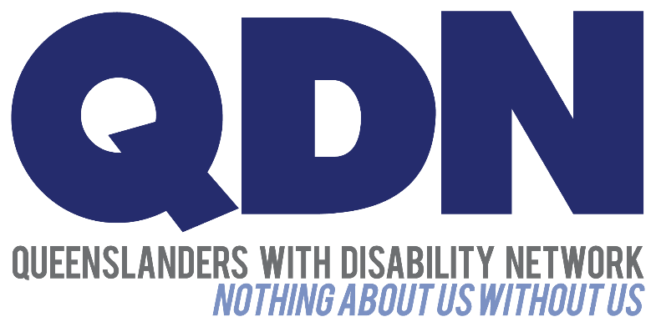
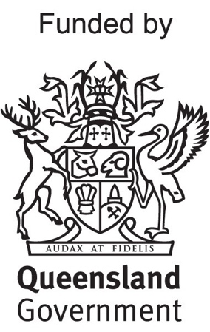
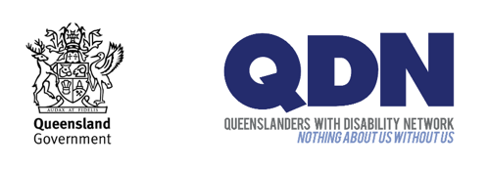
The Queensland Government and Queenslanders with Disability Network (QDN) are working together.


They are working on the Queensland Disability Stakeholder Engagement and Co-Design Strategy. We call this document the Strategy.



A strategy is a plan to help complete a goal.



This Strategy is the plan to deliver on the Queensland Disability Reform Framework in partnership with people with disability.



The Queensland Disability Reform Framework (the Framework) is a plan by the Queensland Government.

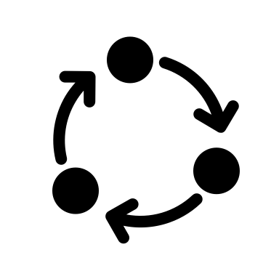
The Framework shows how the Government will put the ideas from the Disability Royal Commission and NDIS Review into action.

We call these actions disability reforms. These are the changes that will happen to make better services and systems for people with disability.
Reform

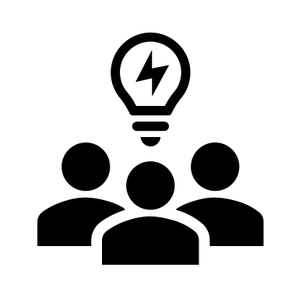

This Strategy is about how people with disability will co-design the disability reforms.


Co-design is a process of people working together.


The Strategy has 5 key areas:
- Governance
- Disability Engagement and Co-Design Hub
- Collaboration and co-design
- Capacity building
- Data collection and assessment



This document will help you understand the Strategy.

In this document we are going to explain each key area.

1 - Governance



Governance is the rules people make about how they work together.

The governance of the Strategy is about:
- how people will work together
- how reports will be written
- how people will make decisions


As part of the Strategy, a Disability Reform Implementation Stakeholder Committee will be formed. We will call this DRISC for short.

DRISC is a group of people that will come together to do a job.

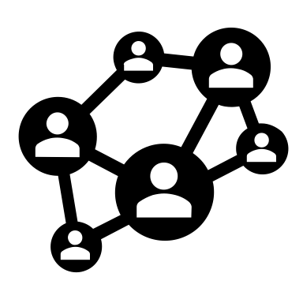
DRISC will include:
- people with disability
- disability advocacy organisations
- service providers
- peak bodies
- community organisations
- Government



Hearing from all these groups will help bring together different points of view.

DRISC will:
- give advice to the Government
- oversee co-design work
- support disability reform in Queensland.

2 - Disability Engagement and Co-Design Hub



The Hub is a place where people come together to meet and work together online and in person.


The Hub is for people to:
- design and test disability reforms
- have their say about disability reform activities
- give feedback about disability reforms


The Hub will help people to work together to do good co-design.

The Hub is for:
- people with disability
- families and carers
- disability advocacy organisations
- service providers
- Government

Lots of different people with disability will be involved:
- Aboriginal and Torres Strait Islander peoples
- women
- children and young people
- LGBTIQIA+ people
- people from culturally and linguistically diverse backgrounds
- people living in regional, rural and remote places
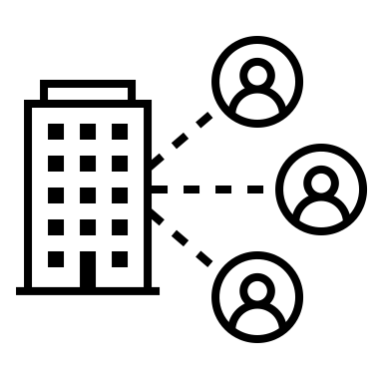

The Hub will work with important groups in the disability community.

The skills and knowledge of disability advocacy organisations will be an important part of work we do together.


The Hub will do lots of different things.
This will include
- bring people together to co-design and share ideas and solutions.
- sharing information about reforms.
- helping people learn about co-design.

3 - Collaboration and co-design approaches


Collaboration is people working together.


The Strategy focuses on the best way of working together.

Co-design is inclusive and brings together:
- Government
- industry
- business
- community organisations
- people with disability and their families and carers

4 - Capacity building



Capacity building is about teaching you and making your skills better.

The Strategy is focused on the skills of:
- people with disability and their families and carers
- Government
- disability advocacy organisations


The Hub will teach about co-design to help build on people’s skills.


The activities will be:
- workshops
- community engagement forums
- online Community of Practice
- online information with research and stories, case studies and resources.

5 - Data collection and assessment



Data is facts and statistics that help people understand if something is working.


We will work to gather good data.

This will help us to know the Strategy is working.

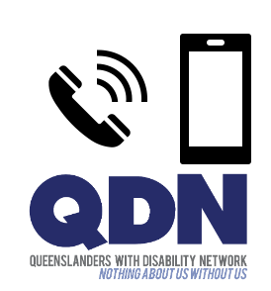

If you have any questions, contact QDN:
- Call 1300 363 783
- Email qdn@qdn.org.au

