QDN Annual Report

This has been a big year for QDN in many different ways.

There has been lots of positive change.

It has been important for us to be strong and work together.

QDN has been a loud voice speaking up about key issues as Queenslanders with disability.

Acknowledgements of Service to QDN Board of Directors

- In June 2024, Gary Matthews who was QDN’s Board Deputy Chairperson passed away.
- Gary was a strong advocate.
- He spoke up about inclusion and access in Queensland.
- In 2023, Jane Britt was on our Board.
- We say thank you to Jane her work on QDN’s Board.

QDN’s achievements of 2023-2024

Game Changers Report: Brisbane 2032
- We worked with Urbis.
- Urbis wrote a report called Game Changers Report: Brisbane 2032.
- This report is about how we need to make change to employment of people with disability.
- This report says we can work together as part of the Olympic and Paralympic Games to get more people into jobs.
- The report talks about what we can do to keep this going after the Games finish.


Queensland Parliamentary Inquiry – Supported Accommodation
- QDN did work as part of Queensland Parliamentary Inquiry.
- This inquiry was looking into what happens for people living in level 1, 2 and 3 supported accommodation facilities.
- The inquiry also made recommendations into what needs to change.
- QDN went to 21 places and spoke to over 500 people living in level 3s.
- QDN helped 132 people tell the Parliament Committee their story and feedback.


Remembering Wendy Lovelace OAM
- QDN’s Board had a lunch to remember and celebrate Wendy Lovelace.
- Wendy was a QDN member and peer leader.
- Wendy died in 2022.
- Wendy did lots of work to make housing and transport more inclusive for people with disability.

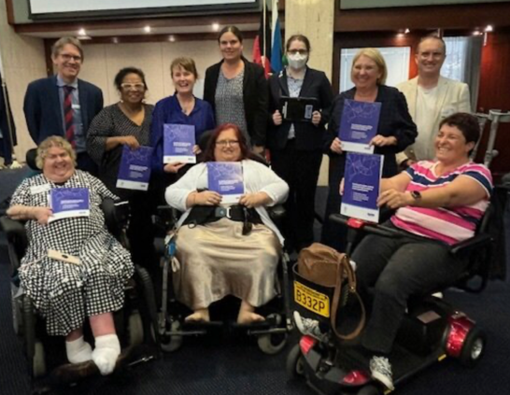
Breaking the Glass Ceiling
- QDN’s Women’s Peer Support Group hosted a workshop on employment and women with disability.
- After the workshop, QDN wrote a paper called Breaking the Glass Ceiling and Smashing the Legacy of Low Expectations.
- The paper talks about feedback from the workshop.
- The paper also talks about ideas to work together to change this.

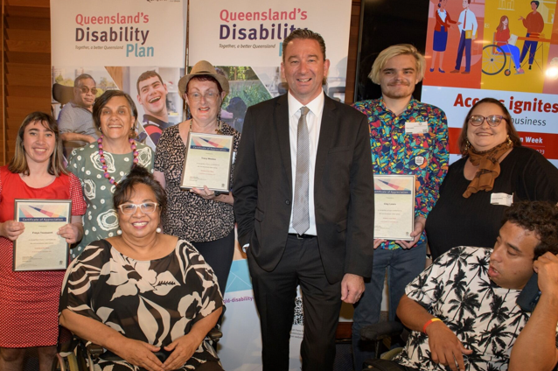
Microbusiness Videos
- QDN worked with people with disability and their families to make some videos.
- These videos were about how people set up their own business. It is called a microbusiness.
- This was launched In November 2023.
- Then-Minister for Child Safety and Minister for Seniors and Disability Services, Craig Crawford MP launched the videos and resources.
- This was funded by Department of Child Safety, Seniors, and Disability Services.
10 Year Research Agenda
- QDN worked with the new National Disability Research partnership (NDRP to be part of some workshops.
- The workshops had important talks about what research is important.



Important moments of 2023-2024
- QDN made over 10 submissions during the Disability Royal Commission.
- QDN held four member forums in November and December 2023.
- These forums talked about the report and recommendations.
- A total of 87 members participated in these forums.
- In March 2024, QDN held a member NDIS Review Forum.
- This talked about provider registration, Foundational Supports, and Housing and Living Supports.
- QDN was asked to bring help find out about what people think about Foundational Supports.
- QDN had meetings with people with disability, families and peak disability organisations.
- QDN had a total of 52 people come to six workshops.

- In 2023 – 2024 QDN played an important role in shaping housing policy. QDN helped co-design the Housing Plan 2024-2027.
- This plan is called Partnering for Inclusive Housing for people with disability.
- QDN is part of the 9 organisations who work on the National Centre of Excellence in Intellectual Disability Health (the Centre).
- The centre was opened on Friday 13 October 2023.
- This was an important day. Lots of people with intellectual disability and their families and workers have worked together on this.


QDN has done the following work from 1 July 2023 to 30 June 2024.

Leadership
- 36 Group Convenors
- 20 Emerging Leaders
- 156 Peer Leaders
- 130 QDeNgage consultants
- 7 Digital Champions
- 16 Disability Inclusive Disaster Risk Reduction (DIDRR) Peer Leaders


DIDRR
- 879 participants attended 86 workshops to develop emergency plans
- 160 participants in 4 Building Inclusive and Disaster Resilient Communities
- 67 P-CEP Peer Leaders throughout Australia completed a capacity building course



AAA Digital Inclusion
- 7 Digital Champions
- 773 devices donated to participants
- 129 workshops held
- 1364 instances of individual support


Policy Contributions
- 39 policy submissions
- Actively participated as a member of 74 committees
- Engaged in 54 consultations
- Delivered 25 presentations



Power of Peers
- 32 peer support groups
- 240 peer support groups meetings
- 1, 700 contacts at meetings



QDeNgage
- 118 projects
- 30 customers
- 787 payments to consultants


QBloggers
- 4 meetings
- 5 blog posts written
- 7 QBlogger actively involved

